301 Howard Street, 21st Floor
San Francisco, CA 94105
Deem Travel Partner Dashboard Training -
Module Two – Travel (Part 1)
Version 16, July 13, 2015

415.590.8300 TEL
415.590.8301 FAX
TABLE OF CONTENTS:

1 Module Series Overview 3
2 Managing the Site Tabs – The Services Tab 4
2.1 Resource Links 4
2.2 Agency Configuration 6
2.2.1 Agency Settings 7
2.2.2 Custom PNR 17
2.2.3 Lists and Sets 19
2.2.4 Queue and Delivery Options 19
2.2.4.1 Queue / Delivery Options List Items 20
2.2.4.2 Queue / Delivery Options Sets 25
2.3 Travel Display Configuration 27
2.3.1 Display Configuration List Items 27
2.3.2 Display Configuration Sets 42
2.4 Custom Fields 42
2.4.1 Custom Field Collections 43
2.4.2 Custom Fields Sets 50
2.5 Restricted Countries 52
2.5.1 Restricted Countries at the Super Domain Level 52
2.5.2 Restricted Countries at the Site Level 54
2.5.3 Restricted Country Examples 57

Module Series Overview
Welcome to Deem’s Basic Dashboard Training.
Whether this is an introduction to the Partner Dashboard or it is a refresher, we are confident that needed information about the dashboard will be gathered during each section of this course.
As an Administrator or Reseller of the Deem Travel application, the basics of administering users, managing policy, understanding customization, reporting features and enabling additional long tail services will be learned. These have all been identified as areas of key customization after the template site has been configured for the successful site administrator.
Classes have been arranged in a logical consecutive flow and will be offered several times each year. The content and learning objectives for each module are designed to stand alone so if necessary, some of the modules can be taken now and others can be attended during later series to complete the course, as time allows. We also offer session recordings that can be downloaded and listened to at a more convenient time.
In preparation for any of the online training sessions, please become familiar with the documentation required for each module.
We are glad you could join us!

Managing the Site Tabs – The Services Tab
The Partner Dashboard at the site level is made up of several tabs. These tabs include the Settings, Users, Services, Groups, Rules, Reports and the Profiles tabs of which all but the Profiles tab will covered in the module series classes. The Profiles tab is covered in the Advanced User Data class.

Resource Links
Resource Links are travel related links that are displayed to the user on the travel planner page. When a new site is created, a generic list of links is included. Customizing or modifying these links is quick and easy.
- Access the Deem Travel Partner Dashboard using the User Name and Password with Users tab permissions.
- The Partner Dashboard Sites | Overview page is displayed. Select the site by clicking the Settings link beside the site.
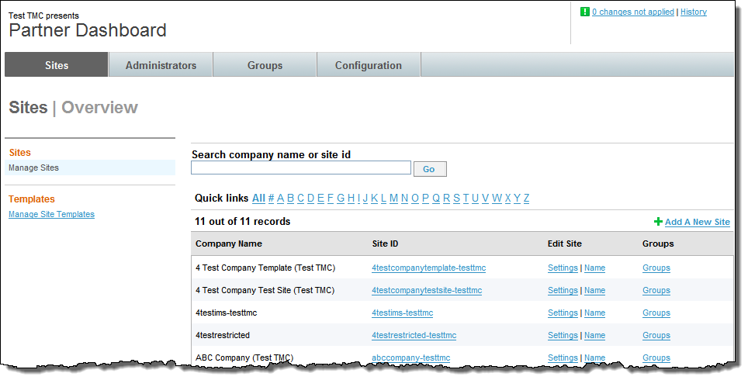
- The Settings tab is displayed. Click the Services tab then the Travel link found above the suitcase.
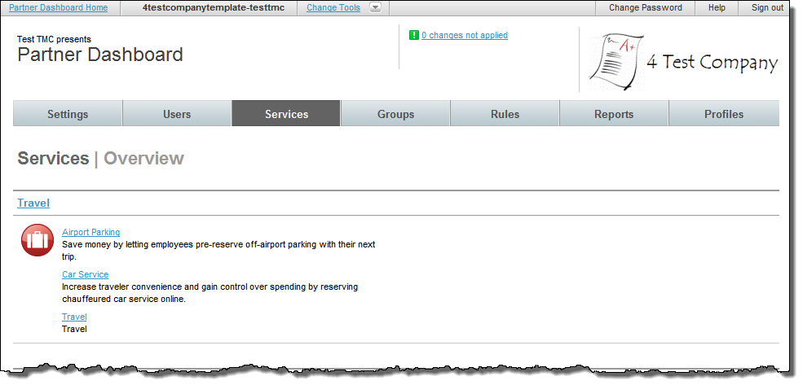
- The Services | Travel Configuration Additional Resource Links page is displayed. Click the Add a New Link link to add a new link.
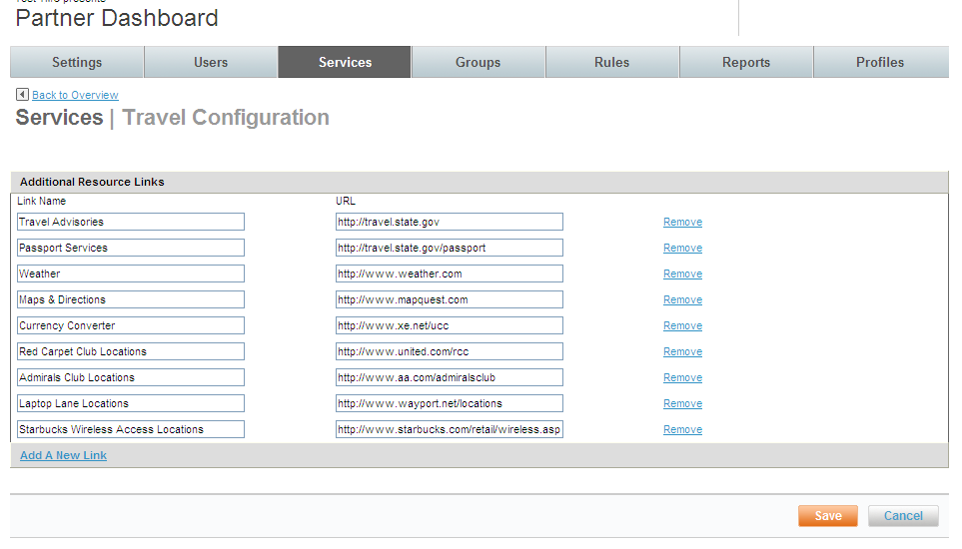
- A new line opens. Enter the resource link information. The link name will be displayed to end-users and the URL will be used to access the site.
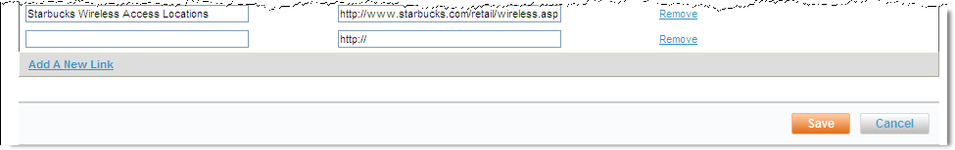
Note: A link can be a company intranet link as well as internet links.
- Click Save to save any changes and remember to commit your changes.

Agency Configuration
When a site is cloned from a template, Agency Configuration settings are cloned too. Most settings can remain the same as those found on the template, but some may need to be adjusted depending on the individual site’s requirements.
- Click the Services tab then the Travel link in the Travel section of the page.
- The Services | Travel page opens. Click the Agency Configuration link.
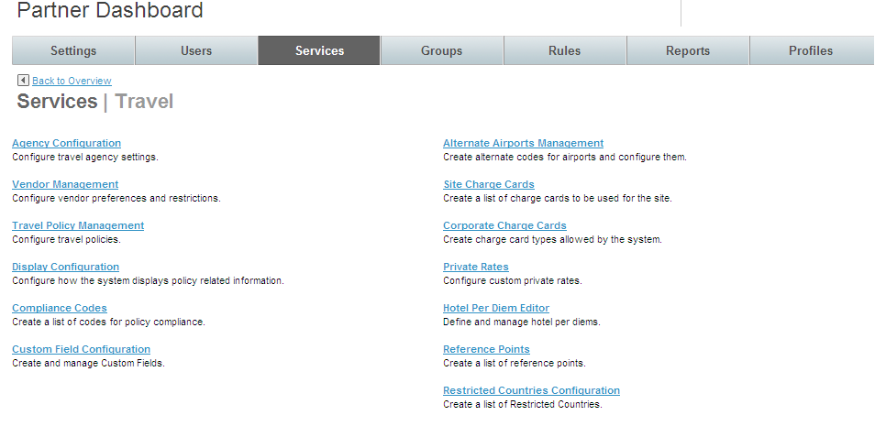
- The Services | Agency Configuration page opens. Click the Agency Settings link.

Agency Settings
Agency specific configuration includes the agency’s PCC, pricing codes and several other agency specific settings.
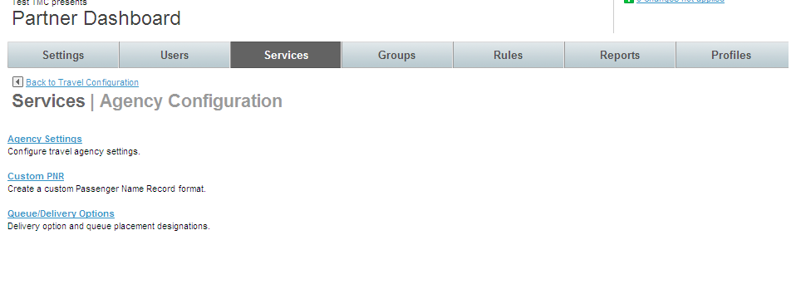
- The Services | Agency Settings page opens. Click Add A New Agency Setting to add a new record, or click the name link of an existing agency setting record to edit that record. The Services | Edit or Add Agency Setting page is displayed.
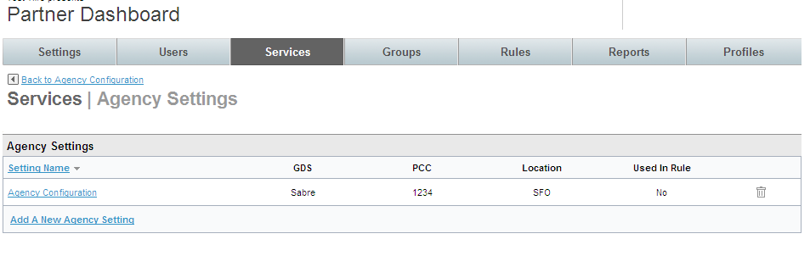
Note: If the site has been cloned, many of these settings will already be in place. Adjustments may only be needed to the agency settings.
- Agency Configuration Settings:
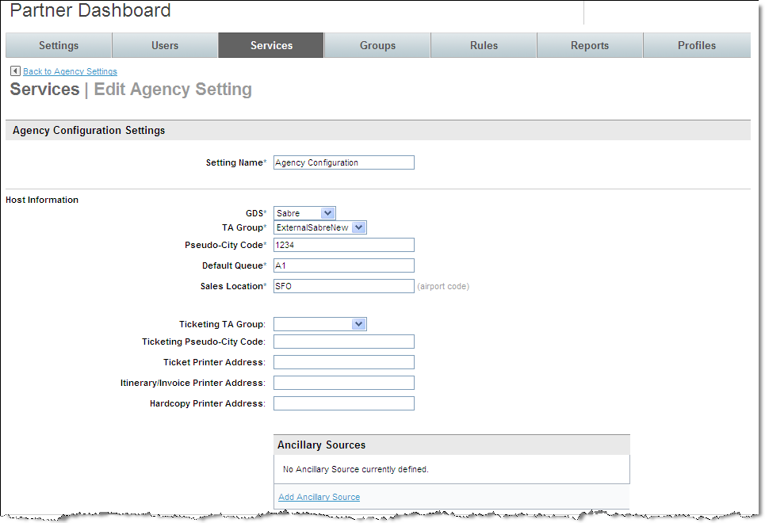
  - Setting Name: (Required) Name the agency configuration. This name should be easily recognizable as a specific agency configuration. An example is Sabre Config to show that this one uses Sabre vs. Worldspan. Other examples of the need for additional agency configurations are different PNR edits, different Pseudo cities or queue delivery options.
- Host Information:
  - GDS: (Required) Select the Global Distribution System from the drop down list.
  - TA Groups: (Required) Terminal Address: Must be set to ExternalSabreNew for Sabre, (ExternalSabre is an old setting) ExternalApollo for Apollo, ExternalGalileo for Galileo or ExternalWorldspan for Worldspan.
  - Pseudo-City Code: (Required) Enter the agency’s pseudo-city code.
  - Default Queue: (Required) Enter the queue to use as a default. This queue can be changed for more specific queue delivery
  - Sales Location: (Required) Enter the airport code associated with the agency’s pseudo-city used for faring with ITA.
  - Ticketing TA Group: Used with void / exchange feature
  - Ticket Printer Address: Used if void / exchange feature is enabled
  - Itinerary / Invoice Printer Address: Used with void / exchange feature
  - Hardcopy Printer Address: Used with void / exchange feature
Note: Enter a ticket and Support will help configure our void / exchange feature
  - Ancillary Sources: Click the Add Ancillary Source link to add a source. The Add Ancillary Source page is displayed. Once the Source has been selected from the drop down list, the remainder of the page will display.
Note: An Ancillary Sourced provider is one that does not use ITA as their fare / availability provider
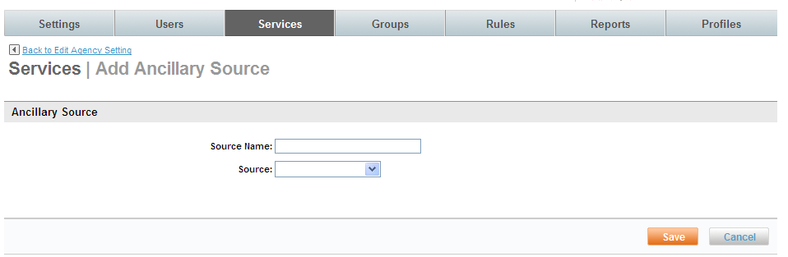
    - Source Name: (Required) Enter the ITA non-participating carrier. (ITA is our shopping and booking tool) GDS or TravelFusion are used to source these carriers. Examples: Southwest (GDS directly) or BMI Baby (TravelFusion).
    - Source: (Required) Select GDS – Apollo, GDS – Galileo, GDS – Sabre, GDS – Worldspan, or Web – TravelFusion from the drop down list.
Note: Other options may be available depending on your site’s configuration.
Note: If GDS: Sabre, Apollo, Worldspan or Galileo are selected the following page is displayed:
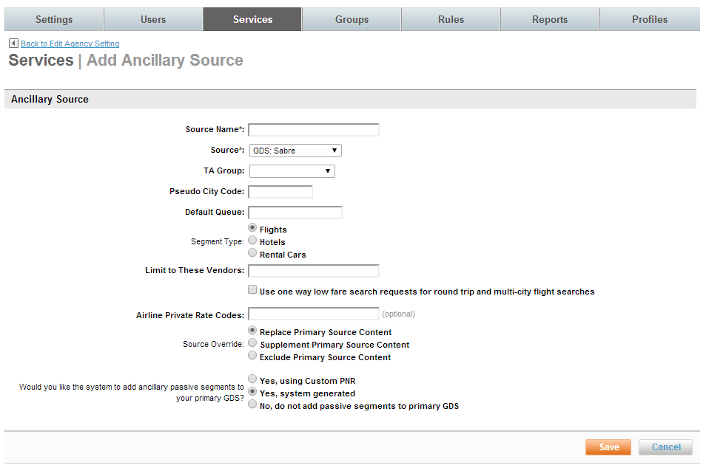
    - TA Group: Select the appropriate TA Group from the drop down list
    - Pseudo City Code: Provide the Pseudo City Code
    - Default Queue: Provide a queue if appropriate
    - Segment Type: Select Flights, Hotels, or Rental Cars from the drop down list.
    - Limit to These Vendors: Enter a list of vendors separated by commas.
    - Use one way low fare search requests for round trip and multi-city flight searches: Select this check box if the same search parameters will be used for a round trip or multi-city search that were used for this leg. Best practice is to use one way low fare search requests.
    - Airline Private Rate Codes: Enter any appropriate Private Rate Codes.
    - Source Override: Select Replace Primary Source Content, Supplement Primary Source Content or Exclude Primary Source Content.
    - Would you like the system to add ancillary passive segments to your primary GDS? Select Yes, using Custom PNR, Yes, system generated, or No, do not add passive segments to primary GDS
Note: It is recommended to select either Yes, system generated, or No, do not add passive segments to primary GDS.
Note: If Source: WEB: TRAVEL fusion is selected, only “Airline”, “Source Override” and “Would you like the system to add ancillary passive segments to your primary GDS fields” are displayed.
Airlines supported include: Aer Arann, Aer Lingus, Air One, Allegiant Air, Azul, bmibaby, Eastern Airways, easyJet, Flybe, Germanwings, Interjet, Jet2, JetBlue, Manx2, Monarch Airlines, Norwegian, Ryanair, TUIfly, Volaris and Wizz Air.
Note: Airlines are added frequently. Please refer to the dashboard for the latest entries.
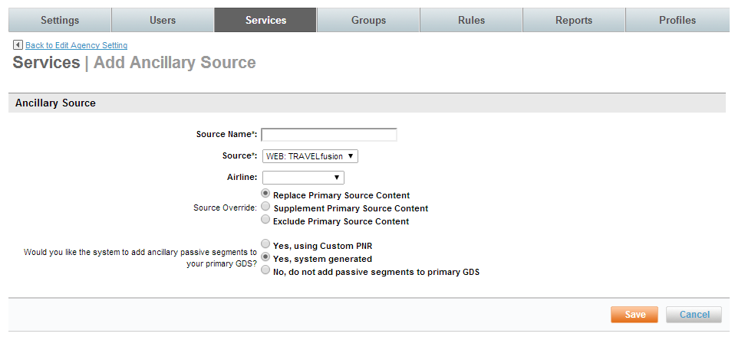
  - Click Save to save the entry. The Services | Add (or Edit) Agency Setting page is redisplayed.
- Agency Information:
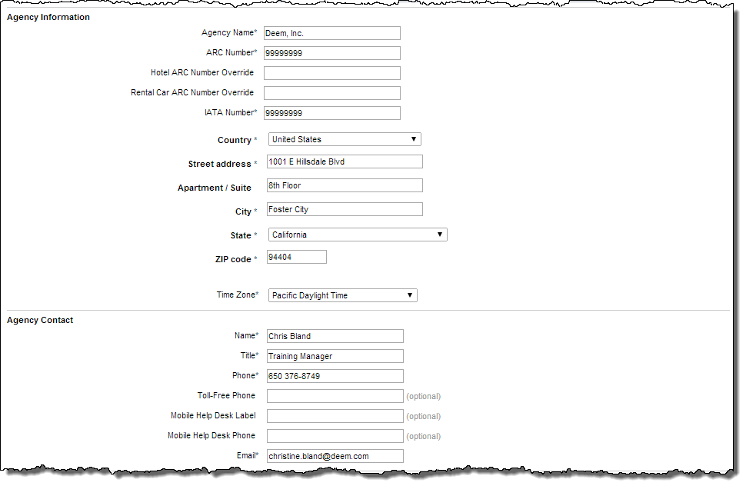
  - Agency Name: (Required) Enter the agency name. Be careful to not exceed 30 characters.
  - ARC Number: (Required) Enter the agency ARC number.
  - Hotel ARC Number: Enter the agency hotel ARC number.
  - Rental Car ARC Number: Enter the agency rental car ARC number.
  - IATA Number: (Required) Enter the agency IATA number.
Note: The IATA number should not include alpha or special characters.
  - Country: Enter the agency country.
  - Street Address: Enter the agency street address.
  - Apartment / Suite: Enter the agency apartment or suite number.
  - City: Enter the agency city.
  - State: Enter the agency state.
  - Zip code: Enter the agency zip code.
  - Time Zone: (Required) Enter the agency time zone used for ticketing cancelation.
- Agency Contact:
  - Name: (Required) Enter the contact name. This name will display on the Trip Confirmation Page and print on the trip’s itinerary.
  - Title: (Required) Enter the contact title. This information is used by Deem internal personnel for reference only.
  - Phone: (Required) Enter the contact phone number. This phone number will display on the Trip Confirmation Page and print on the trip’s itinerary.
  - Toll-Free Phone: Enter the contact toll free phone number. This phone number will display on the Trip Confirmation Page and print on the trip’s itinerary.
  - Email: (Required) Enter the contact email address. This information is used by Deem internal personnel for reference only.
- Message to Users (Optional):
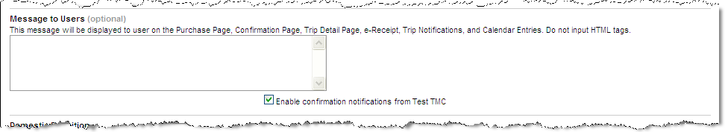
  - Text box provided: Enter a message to display to users on the Purchase Page, Confirmation Page, Trip Detail Page, e-Receipt, Trip Notifications, and Calendar Entries. Do not use HTML tags or Travel lingo.
  - Enable confirmation notifications from site name: Click this checkbox to enable email confirmations to be sent from this site.
Note: It is Recommended this checkbox be selected.
- Domestic Definition:
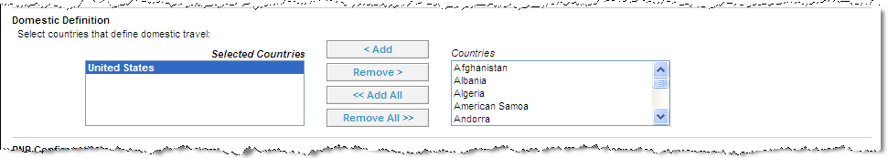
  - Select the countries that define domestic travel and click Add to move them to the Selected Countries box. These countries will fall under the domestic travel requirements. All others will be considered International.
Note: Search results windows and Queue Delivery Options may differ depending on the domestic / international designation.
- PNR Configuration:
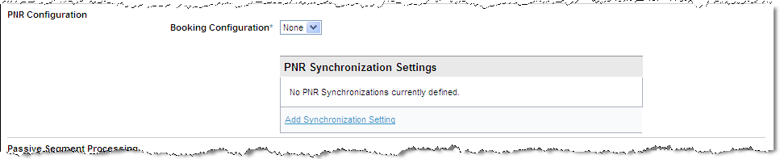
  - Booking Configuration: Select a PNR edit configuration from the drop down list for this agency. This identifies what PNR edit sets to use for this agency configuration.
  - PNR Synchronization Settings: Add the GDS to use for PNR synchronization. Click the Add Synchronization Settings link. The Services | Add PNR Synchronization page is displayed.
Note: It is recommended PNR Synchronization be enabled for ONE SITE only if all properties are the same across the sites. Enabling PNR synchronization on multiple sites adds unnecessary GDS churn.
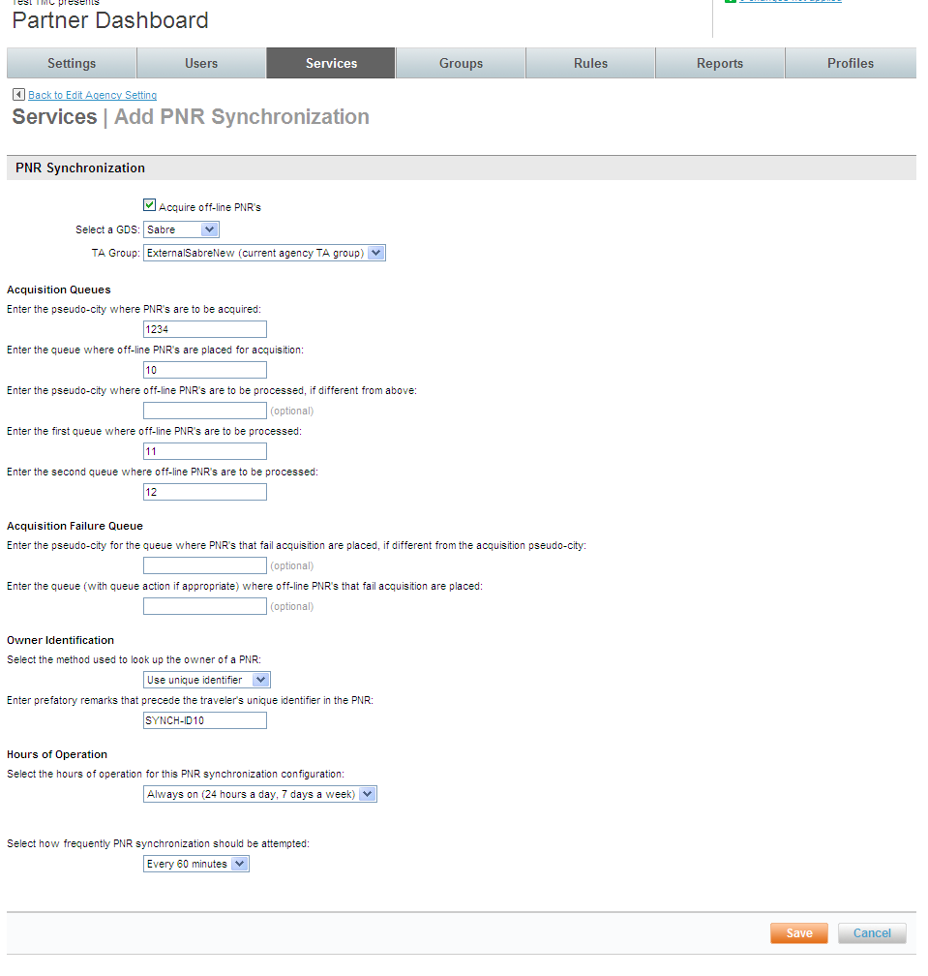
    - Acquire off-line PNR’s: Select the checkbox to acquire off-line PNR’s.
    - Select the GDS: Select the GDS from the drop down list
    - TA Group: Must be set to ExternalSabreNew for Sabre, (ExternalSabre is an old setting) ExternalApollo for Apollo, ExternalGalileo for Galileo or ExternalWorldspan for Worldspan.
    - Acquisition Queues:
      - Enter the Pseudo-city where PNR’s are to be acquired: Enter the pseudo-city code
      - Enter the queue where off-line PNR’s are placed for acquisition: Enter the first queue to use for off-line PNR’s.
      - Enter the Pseudo-city where PNR’s are to be processed if different from above: Enter the pseudo-city code to use for processing if different from acquisition pseudo-city.
      - Enter the first queue where off-line PNR’s are to be processed: Enter the first queue to use for off-line PNR processing.
      - Enter the second queue where off-line PNR’s are to be processed: Enter the second queue to use for off-line PNR processing.
    - Acquisition Failure Queue:
      - Enter the pseudo-city for the queue where PNR’s that fail acquisition are placed, if different from the acquisition pseudo-city: Enter the pseudo-city to use for failed synch requests.
      - Enter the queue (with queue action if appropriate) where off-line PNR’s that fail acquisition are placed: Enter the queue to use for failed synch requests.
Note: It is the responsibility of the agency to monitor failed acquisitions.
    - Owner Identification:
      - Select the method used to look up the owner of a PNR: This is set during implementation and there is no need to change. It is a Best Practice to use “Unique Identifier”.
If “Unique Identifier” or “Login Name” were selected, an additional text box is displayed.
Enter prefatory remarks that precede the traveler’s _____ in the PNR.
    - Hours of Operation: Our scripts run every hour on the half hour. If scripts are to run more or less frequently or at a different time configure the timing here.
      - Select the hours of operation for this PNR synchronization configuration: Select Always On or Specific Hours and then define the hours of operation.
      - Select how frequently PNR synchronization should be attempted: Select the frequency to use for synchronization.
Note: Please remember that each time PNR synchronization is triggered there are GDS hits and this can incur charges. We recommend setting the interval to no more than every 60 minutes.
Note: When an error occurs during PNR synchronization, a Passive segment can be created, depending on if passive segments were enabled during the Agency Display Configuration.
- Passive Segment Processing: Not used very often. If passive segments will be used, Deem Configuration Team can assist in creating this JavaScript.
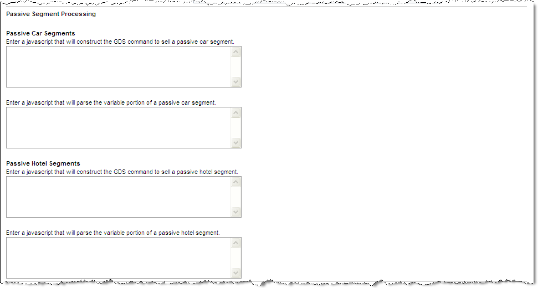
  - Passive Car Segments: No longer used.
  - Passive Hotel Segments:
    - Enter a JavaScript that will construct the GDS command to sell a passive hotel segment: When passive segments are enabled, JavaScript entered here is used to process the passive segment.
    - Enter a JavaScript that will parse the variable portion of a passive hotel segment: If an error occurs during PNR synch due to agency unique requirements, enter JavaScript here that re-write the script for the PNR to succeed.
- Travel Settings:
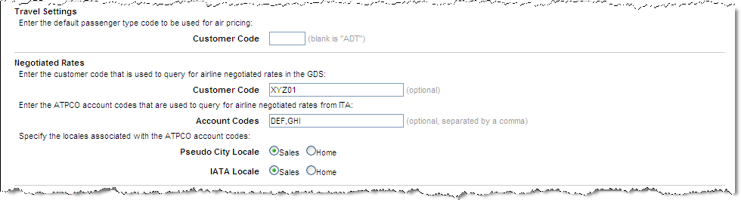
  - Enter the default passenger type code to be used for air pricing:
    - Customer Code: (blank is “ADT”) If not code is entered, the default is Adult.
- Negotiated Rates
  - Enter the customer code that is used to query for airline negotiated rates in the GDS: This code will be sent to the GDS to retrieve the negotiated rates.
  - Enter the ATPCO account codes that are used to query for airline negotiated rates from ITA: This code will be sent to ITA to retrieve the negotiated rates.
  - Specify the locales associated with the ATPCO account codes:
    - Pseudo City Locale: Sales or Home. Generally Sales is selected.
    - IATA Locale: Sales or Home. Generally Sales is selected.
- Train Support:
Note: To enable VIARail in Canada, complete the Train Support section as you would for US’s Amtrak. However, the Sales Location found at the top of the Agency Settings page must be a Canadian airport code.
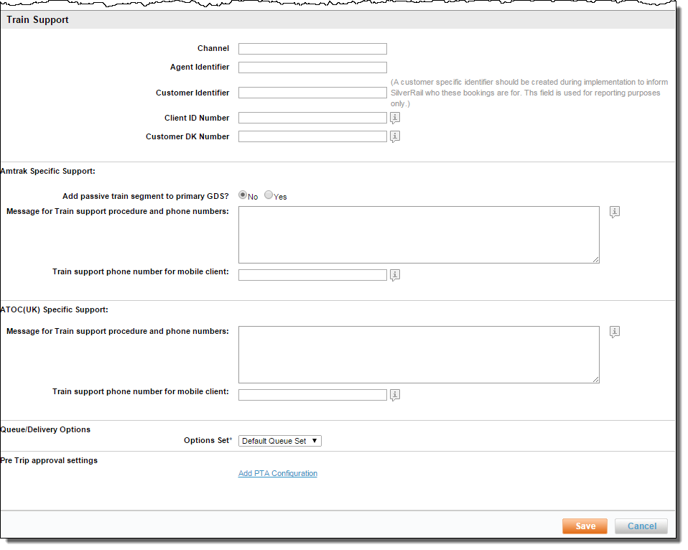
  - Channel: Enter the SilverRail supplied Channel code. (AXIOM, REARDEN or TVLPORT if the site is not using a site card. AXIOMSC, REARDENSC or TVLPORTSC if using a site card.). Must be all caps.
  - Agency Identifier: Enter the SilverRail supplied Agency Identifier. Must be all caps.
  - Customer Identifier: Enter the SilverRail supplied Customer Identifier. Must be all caps. This identifier defines a specific customer and should be created during implementation. The field is used for reporting only.
  - Client ID Number: Enter the number to be used when optional reporting is required.
  - Customer DK Number: Enter the number to be used when optional reporting is needed.
- Amtrak Specific Support:
  - Add passive train segment to primary GDS?: Yes or No.
  - Message for Train support procedure and phone numbers: Enter the message to be displayed to the traveler on the purchase page and on confirmation messages. Do not include HTML tags or travel lingo.
  - Train support phone number for mobile client: Enter the phone number to be displayed in the mobile client if the number is different from other support numbers
- ATOC(UK) Specific Support:
  - Message for Train support procedure and phone numbers: Enter the message to be displayed to the traveler on the purchase page and on confirmation messages. Do not include HTML tags or travel lingo.
  - Train support phone number for mobile client: Enter the phone number to be displayed in the mobile client if the number is different from other support numbers.
- Queue / Delivery Options
  - Options Set: (Required) Select the pre-defined Queue / Delivery Options Set for PNR (for ticketing, invoice, etc.) processing.
- Pre Trip approval settings: Click the Add PTA Configuration link to access Pre-trip approval settings.
Note: For more information about PTA, please contact your Account Success or Sales Manager.
- Click Save to save the changes. Click the “_ changes not applied” link to commit the changes.
- The changes made since the last time a commit was done are displayed. Click the Commit button to commit the changes to the database.

Custom PNR
Custom PNR string edits are performed to complete the GDS reservation. This allows the PNR to be sent to GDS with very little agency touch. The configuration can contain basic information like adding a cost center to a name field or can be more complex, like documentation for ticket exchanges. In general, custom PNR strings are created by the Deem configuration team during the site implementation process. Modification to PNR strings are the responsibility of the client, however, Deem is available to assist in any needed changes.
To determine which PNR edit strings are needed, Deem studies a typical agency booking and attempts to duplicate standard entries. This could include UDIDs, specialized cost savings documentation and variable credit cards options based on departmental requirements.
To access the PNR string edits:
- Click the Services tab then the Travel link. The Services | Travel page is displayed.
- Click the Agency Configuration link. The Services | Agency Configuration page is displayed.
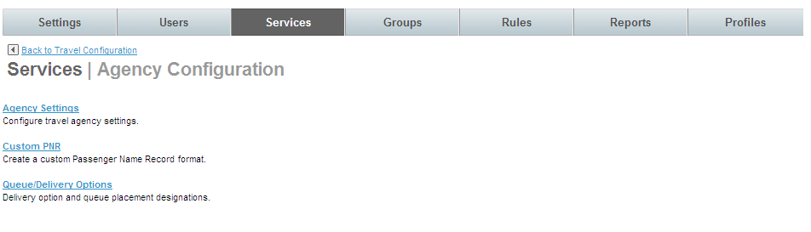
- Click the Custom PNR link. The Services | Custom PNR Configurations page is displayed. Click the link below a Set Name to view the configuration or click the Add a New PNR Configuration to add a new one.
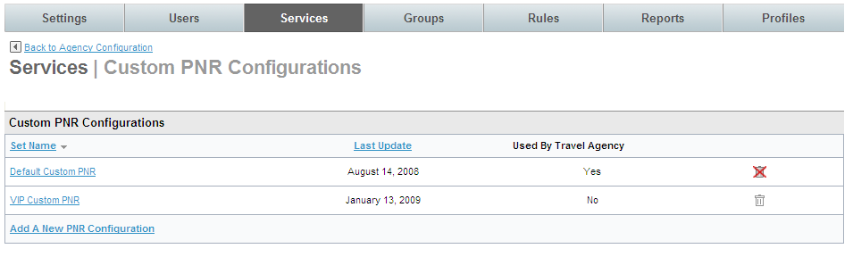
- The Services | Add (or Edit) PNR Configurations page is displayed.
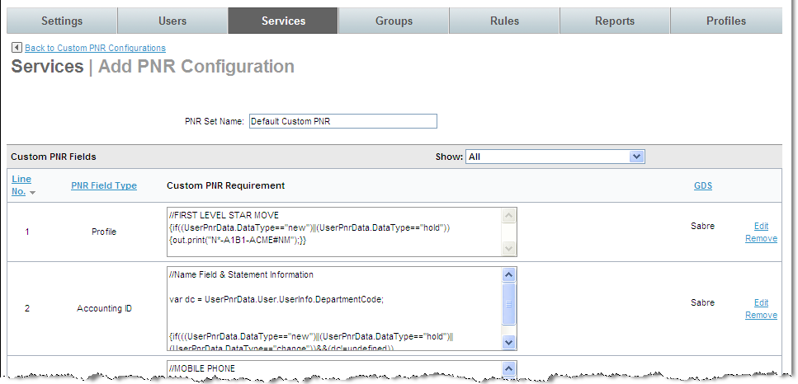

Lists and Sets
The List and Set structure is used throughout the Deem Dashboard.
Using travel policy as an example, a List could be the policy set up for the general population of travelers. A second list could be the policy set up for VIP travelers and so on.
A Set is a holder, or a “bucket”, into which related lists can be placed. Continuing with the travel policy example, the two lists mentioned (general population travelers and VIP travelers) could be placed in a Set titled Domestic Travelers. If travel policies were then created for internationally based travelers, a set could be created to hold those lists.
Once details have been defined (the list), add them to the holder (set) for use when configuring travel policy. In the dashboard a link for Lists and Sets will be seen under many of the Services functions.
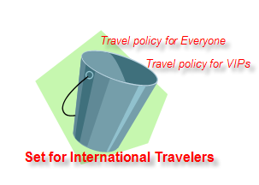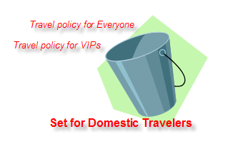

Queue and Delivery Options
Once the PNR is complete, the record must be sent to a queue for processing. It can be sent to the default queue set up on the Agency Configuration, or there can be a different queue set up in this link.
A separate list must be created for each unique delivery requirement. An example is where an airport requires a paper ticket. A list specific to this requirement must be created.
- From the Services tab click the Travel link in the Travel section of the page. The Services | Travel page opens.
- Click the Agency Configuration link. The Services | Agency Configuration page opens.
- Click the Queue / Delivery Options link. The Services | Queue / Delivery Options page is displayed.
- Click the Queue / Delivery Options link.

Queue / Delivery Options List Items
Note: Queue / Delivery Options follow the List and Set structure discussed earlier. First we will look at the List of options.
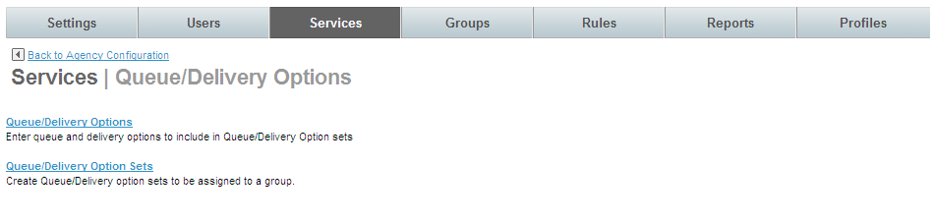
- The Services | Queue / Delivery Options page is displayed.
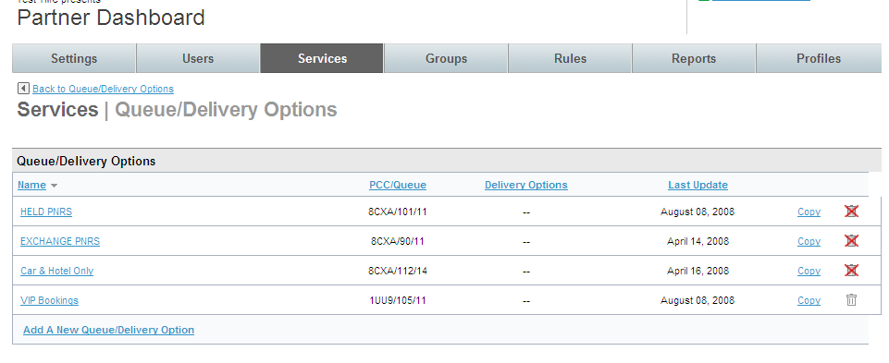
Note: A PNR must meet ALL of the conditions outlined in queue / delivery options
- Click the Add Queue / Delivery Option link to add a new option, or click the name link to edit an existing one. The Services | Add (or Edit) Queue / Delivery Options page is displayed.
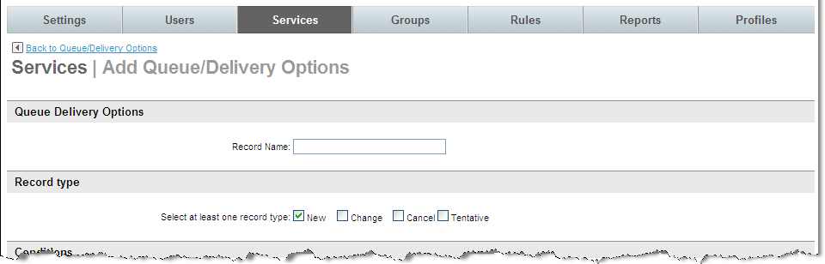
- Complete the page:
- Queue Delivery Options
  - Record Name: Enter a record name that will be easily recognizable for the queue.
- Record Type: Select at least one record type: New, Change, Cancel, or Tentative. This is the type of PNR that the queue delivery option applies to.
- Conditions: Set the requirements that must be met by a PNR before the PNR will be placed in this queue.
REMEMBER: ALL conditions must be met for PNR’s to fall into this queue.
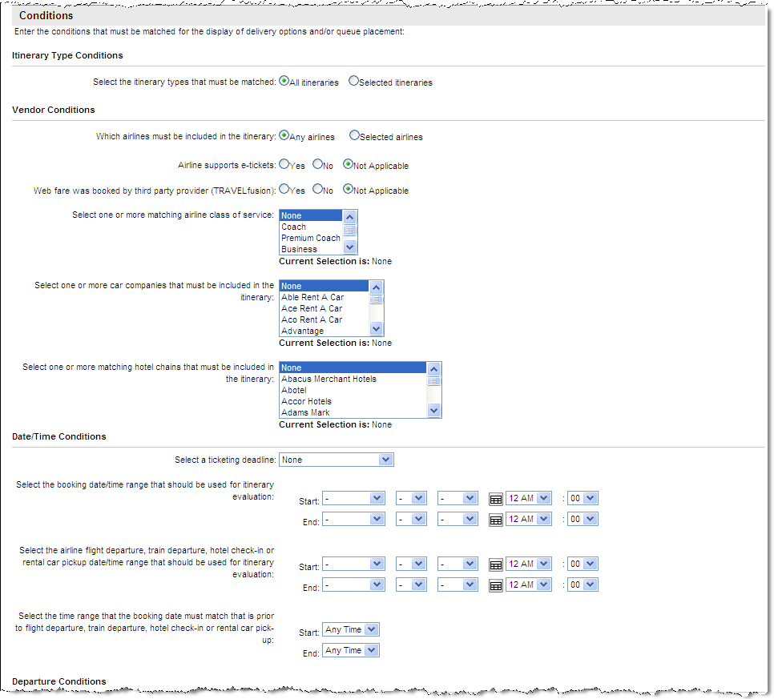
  - Itinerary Type Conditions: Select either All itineraries or Selected itineraries. If Selected itineraries is chosen, select the itinerary guideline(s) such as Itineraries with air segments - from the drop down list. Multiple guidelines may be selected by using the control key. Select one or more from the drop down list:
    - Itineraries with at least one international segment
    - Itineraries with no international segments
    - Itineraries with a car segment
    - Itineraries with a hotel segment
    - Itineraries with a private rate hotel
    - Itineraries with passive segments
    - Itineraries with hotel only
    - Itineraries with car only
    - Itineraries with car and hotel only
    - Itineraries with rail segments
    - Itineraries with air segments
  - Vendor Conditions:
    - Select either All airlines or Selected airlines. If Selected airlines was chosen, select the airline(s) from the drop down list. Multiple airlines may be selected by using the control key.
    - Also choose how the airline participates in the itineraries.
      - Airline supports e-tickets: Select Yes, No or Not Applicable
      - Select one or more matching airline class of service: Select the class of service from the drop down list. Choose more than one class by holding down the control key.
      - Select one or more car companies that must be included in the itinerary: Select the car company from the drop down list. Choose more than one by holding down the control key.
      - Select one or more hotel chains that must be included in the itinerary: Select the hotel chain from the drop down list. Choose more than one by holding down the control key.
  - Date / Time Conditions:
    - Select a ticketing deadline from the drop down list. None, Any day after tomorrow, Today or Tomorrow.
    - Select a booking date / time range that should be used for itinerary evaluation from the drop down lists.
    - Select the airline flight departure, hotel check-in or rental car pickup date / time range that should be used for itinerary evaluation from the drop down lists.
    - Select the time range that the booking date must match that is prior to flight departure, hotel check-in or rental car pick-up from the drop down lists.
  - Departure Conditions:
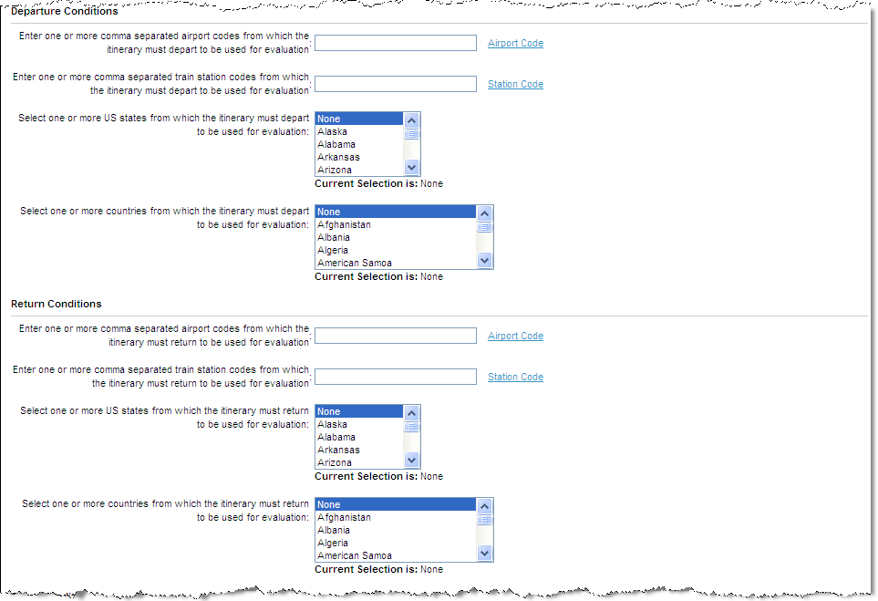
    - Enter one or more comma separated airport codes from which the itinerary must depart to be used for evaluation: Enter the airport code(s). Multiple airports may be selected by using the control key.
    - Select one or more US states from which the itinerary must depart to be used for evaluation: Select the state(s) from the drop down list. Choose multiple states by using the control key.
    - Select one or more country from which the itinerary must depart to be used for evaluation: Select the country from the drop down list. Choose multiple countries by using the control key.
  - Return Conditions:
    - Enter one or more comma separated airport codes from which the itinerary must return to be used for evaluation: Enter the airport code(s). Choose multiple airports by using the control key.
    - Select one or more US states from which the itinerary must return to be used for evaluation: Select the state(s) from the drop down list. Select multiple states by using the control key.
    - Select one or more country from which the itinerary must return to be used for evaluation: Select the country from the drop down list. Select multiple countries by using the control key.
  - Other Conditions:
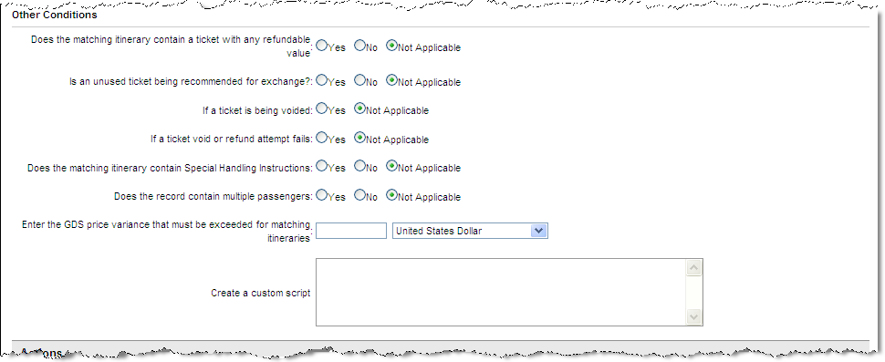
    - Does the matching itinerary contain a ticket with any refundable value: Select Yes, No or Not Applicable.
    - Is an unused ticket being recommended for exchange: Select Yes, No or Not Applicable.
    - If a ticket is being voided: Select Yes, No or Not Applicable.
    - Does the matching itinerary contain Special Handling Instructions: Select Yes, No or Not Applicable.
    - Does the record contain multiple passengers: Select Yes, No or Not Applicable.
    - Enter the GDS price variance that must be exceeded for matching itineraries: Enter the price variance and select a unit of measure from the drop down list.
    - Create a custom script: Enter a custom script to define the requirement for this queue. The Deem Configuration Team can help with this.
- Actions: The following actions will take place if ALL the above conditions are met:
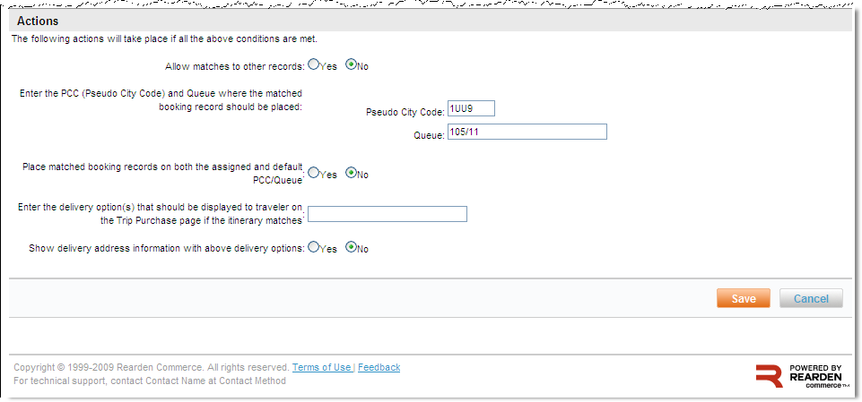
  - Allow matches to other records: Select Yes or No. Is a PNR allowed to go to more than one queue? If Yes is selected, the PNR will go to other queues. If No is selected, the PNR will go to the most restrictive queue.
    - Enter the PCC and Queue where the matched booking record should be placed: Enter a pseudo city code and queue name.
    - Place matched booking records on both the assigned and default PCC/Queue: Select Yes or No. The default queue is the queue assigned on the Agency Settings page.
    - Enter the delivery option(s) that should be displayed to traveler on the Trip Purchase page if the itinerary matches: Enter text that does not include travel lingo or HTML tags.
    - Show delivery address information with above delivery options: Select Yes or No. An example of when a delivery address is needed would be for a paper ticket.
- Click the Save button to save the configuration. The Services | Queue / Delivery Options page is redisplayed. Click the Back to Queue / Delivery Options link at the top of the page. (NOT the browser Back button)
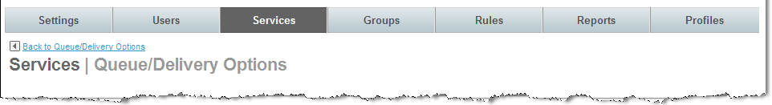

Queue / Delivery Options Sets
Note: Next, add the List (queue policy detail) to a Set.
- Click the Queue / Delivery Option Sets link. The Services | Queue / Delivery Option Sets page is displayed.
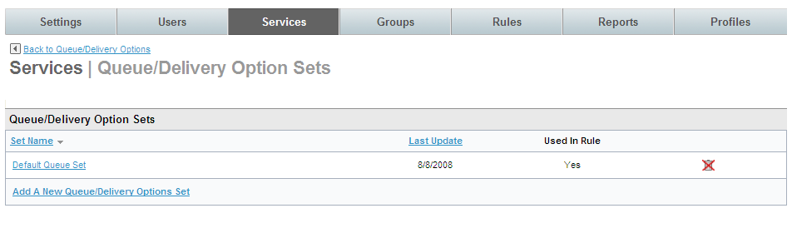
- Click the Add Queue / Delivery Options Set link or select a set name to add a List to an existing set. The Services | Add Queue / Delivery Option Sets page is displayed.
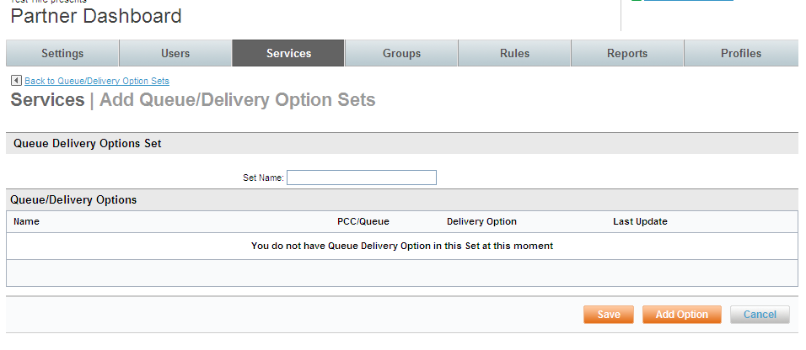
- Enter a Set Name and click the Add Option button to add list items to the set. The Services | Search & Add Queue / Delivery Options page is displayed.
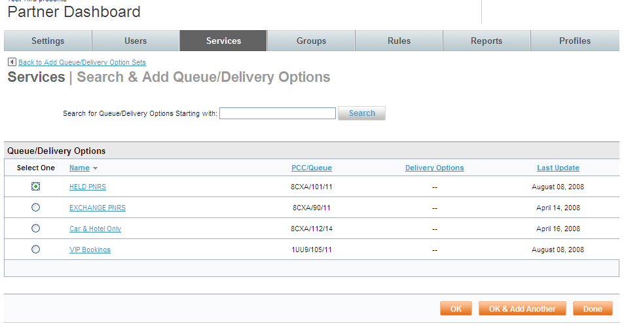
- Select a list item by clicking the radio button beside it and clicking the OK button if only one list is to be added to the set or the OK & Add Another button to add this one list and then another one to the set. Repeat this step for each item to be added. When selection of lists to add to the set has been completed, click the OK button.
- Click Save to save the set. Click the “_ changes not applied” link to commit the changes.
- The changes made since the last time a commit was done are displayed. Click the Commit button to commit the changes to the database.

Travel Display Configuration
What the traveler will see on the Travel Page of Deem is determined by settings in the Display Configuration. When a site is created, default display settings are pre-configured based on the template used to clone the site, or if the site was not the result of a template clone, the settings are the Deem defaults.
Once the Display Configurations have been set up, they are assigned to groups of travelers. When a site is created, the Everyone Group is established, but as the need for different travel requirements arise, new groups can be added. An example would be the VIP group. Groups are discussed in a later module.
- Click the Services tab then the Travel link in the Travel section of the page.
- The Services | Travel page is displayed. Click the Display Configuration link.
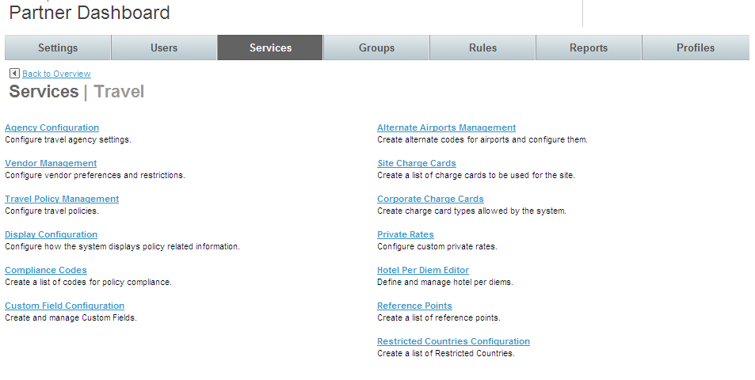
- The Services | Display Configuration Management page is displayed.
Note: The Display Configuration page follows the List and Set structure discussed earlier. First we will look at the List of options.

Display Configuration List Items
- Click the Display Configuration List link.
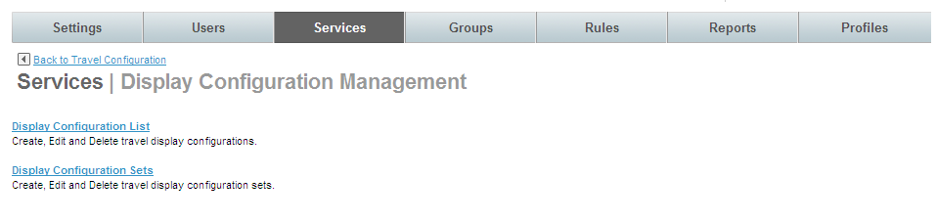
- The Services | Display Configuration List page is displayed. The records displayed are the individual display policies established for this site. Click the Add A New Display Configuration link to add a new configuration or click the Configuration Name link to display an existing list.
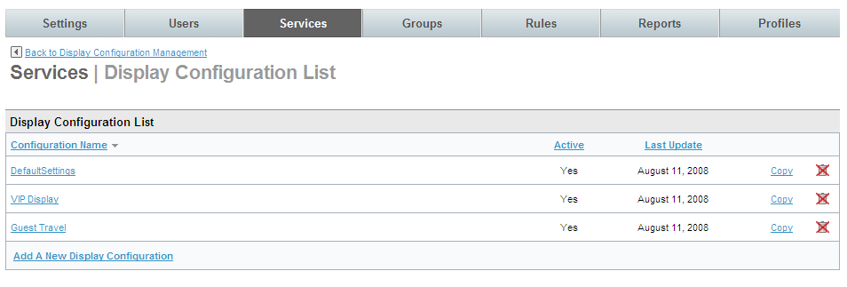
- The Services | Add or Edit page is displayed. Complete the page:
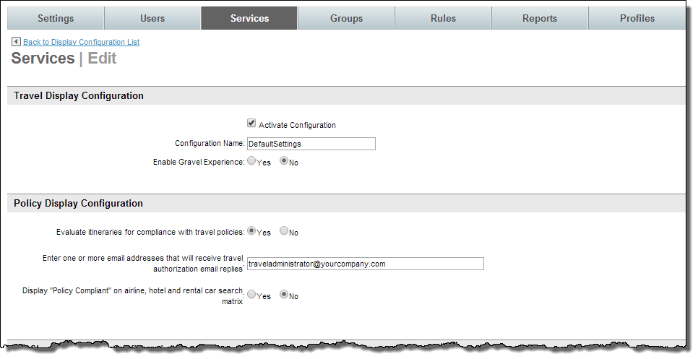
- Travel Display Configuration:
  - Activate Configuration: Select this checkbox to activate the display policy
  - Configuration Name: Enter a name for this display policy that will be meaningful when displayed in a list.
  - Enable Gravel Experience: Yes or No. This is reserved for future use.
- Policy Display Configuration:
  - Evaluate itineraries for compliance with travel policies: Yes or No. Selecting Yes will review all itineraries and flag out of policy trips.
  - Enter one or more email addresses that will receive travel authorization email replies: This field is currently not used, but an email address must be entered because this is a required field.
  - Display “Policy Compliant” on airline, hotel and rental car search matrix: Yes or No. This works in conjunction with Evaluate itineraries for compliance with travel policies: Yes or No above. If a trip is within policy, the message “Policy Compliant” will be displayed.
- Air Shopping Display Configuration:
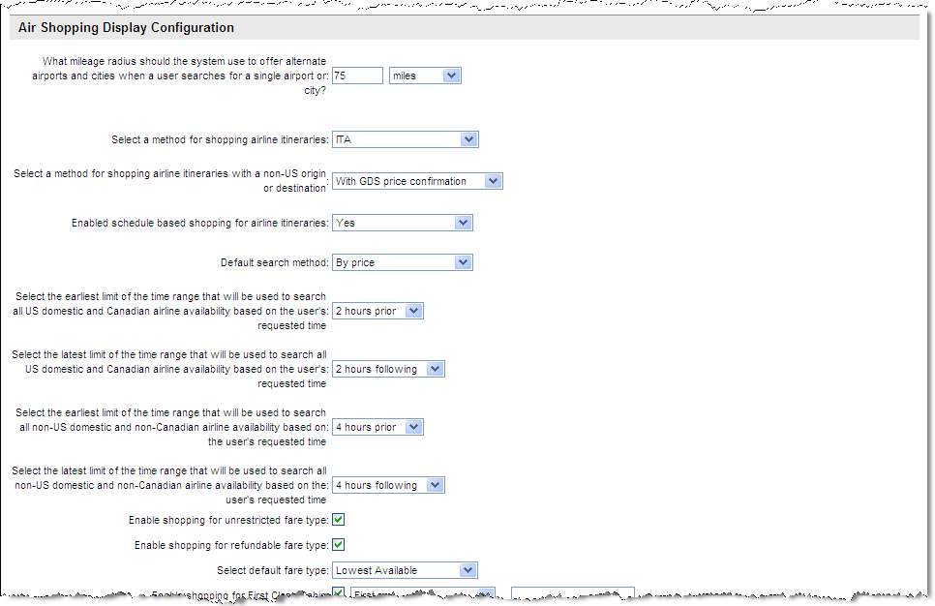
  - What mileage radius should the system use to offer alternate airports and cities when a user searches for a single airport or city? Enter the number of miles away from the searched for airport that alternative airports will be displayed. Also select the unit of measure to use when displaying the distance. It is recommended that 60 – 75 miles be used to limit the number of returned flights.
  - Select a method for shopping airline itineraries: Use super domain method or ITA are recommended methods.
  - Select a method for shopping airline itineraries with a non-US origin or destination: With GDS price confirmation is the recommended setting.
  - Enabled schedule based shopping for airline itineraries: May select Use superdomain setting, Yes or No. Alternative is By Price.
  - Default search method: May select User superdomain setting, by price or by schedule
  - Select the earliest limit of the time range that will be used to search all US domestic and Canadian airline availability based on the user’s requested time: Times range from 1 hour to 1 day in hour increments. It is recommended that 2 hours be selected.
  - Select the latest limit of the time range that will be used to search all US domestic and Canadian airline availability based on the user’s requested time: Times range from 1 hour to 1 day in hour increments. It is recommended that 2 hours be selected.
  - Select the earliest limit of the time range that will be used to search all non-US domestic and non-Canadian airline availability based on the user’s requested time: Times range from 1 hour to 1 day in hour increments. It is recommended that 4 or 5 hours be selected because of fewer available flights.
  - Select the latest limit of the time range that will be used to search all non-US domestic and non-Canadian airline availability based on the user’s requested time: Times range from 1 hour to 1 day in hour increments. It is recommended that 4 or 5 hours be selected because of fewer available flights.
  - Enable shopping for unrestricted fare type: Display unrestricted fares?
  - Enable shopping for refundable fare type: Display refundable fares?
  - Select default fare type: Select Lowest Available, Fares with no restrictions, or Fares that allow refunds.
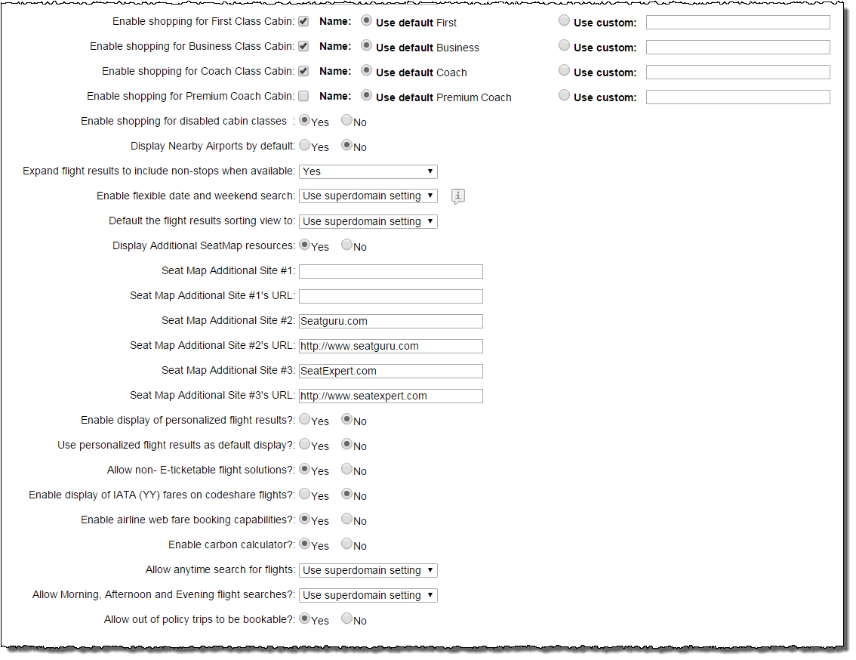
  - Enable shopping for First Class Cabin: Select the Name: checkbox if this class of service will be displayed. Select the Use default radio button to use the default name, or if a custom name is to be displayed, select the Use custom radio button and enter the name in the box provided.
  - Enable shopping for Business Class Cabin: Select the Name: checkbox if this class of service will be displayed. Select the Use default radio button to use the default name, or if a custom name is to be displayed, select the Use custom radio button and enter the name in the box provided.
  - Enable shopping for Coach Class Cabin: Select the Name: checkbox if this class of service will be displayed. Select the Use default radio button to use the default name, or if a custom name is to be displayed, select the Use custom radio button and enter the name in the box provided.
  - Enable shopping for Premium Coach Cabin: Select the Name: checkbox if this class of service will be displayed. Select the Use default radio button to use the default name, or if a custom name is to be displayed, select the Use custom radio button and enter the name in the box provided.
Note: Any or all of the cabin classes may be selected for this configuration. These radio buttons only enable the display of the classes of service. They do not govern policy around the selections made by the traveler.
  - Enable shopping for disabled cabin classes: Yes or No. Will classes not selected be displayed to the traveler?
  - Display Nearby Airports by default: Yes or No. Will nearby airports be automatically displayed to the traveler, or will they need to select the Nearby Airports checkbox while shopping for flights?
  - Expand flight results to include non-stops when available: Selecting Use superdomain setting or Yes will allow the search results to be expanded to show non-stops when the search criteria otherwise would not have returned them. Selecting No will not expand the search results.
  - Enable flexible date and weekend search: Selecting Use superdomain setting or Yes will display a matrix of flights available over several days to allow selection of the best flight solution. Selecting No will not display the matrix.
  - Default the flight results sorting view to: Select Use superdomain setting, Policy / Preferred, Cost, Departure, Arrival, Duration from the drop down list to display search results in a defaulted sort.
  - Display Additional SeatMap resources: Yes or No. Deem provides a general seat map for each type of plane. Additional information such as recline angle or knee space can be found on the web.
  - Seat Map Additional Site #1: Enter the name to display on Deem for this web site.
  - Seat Map Additional Site #1 URL: Enter the URL for the seat map web site.
  - Seat Map Additional Site #2: Enter the name to display on Deem for this web site.
  - Seat Map Additional Site #2 URL: Enter the URL for the seat map web site.
  - Seat Map Additional Site #3: Enter the name to display on Deem for this web site.
  - Seat Map Additional Site #3 URL: Enter the URL for the seat map web site.
  - Enable display of personalized flight results?: Yes or No.
  - Use personalized flight results as default display?: Yes or No.
  - Allow non-E-ticketable flight solutions? Yes or No.
  - Enable display of IATA (YY) fares on codeshare flights: Yes or No. This toggle enables or blocks faring solutions from ITA where the plating carrier has fares filed but no permission to issue tickets. An Example is the LHRFRA market where UA has fares filed for LH code share flights but an agency should not issue tickets on UA stock.
  - Enable airline web fare booking capabilities: Yes or No. Web fares would include VMI Baby, Ryan Air and Easy Jet.
  - Enable carbon calculator: Yes or No. A calculation of the pounds of carbon dioxide used for the trip is displayed to the traveler.
  - Allow anytime search for flights: Currently the Air search time is set to be Morning (6am – 12pm) for departures and Evening (6pm – 12am) for return flights. Selecting Use superdomain setting or Yes will expand the display of flight search results to all available flights for the day of travel. The drop down will remain available to the traveler to select specific times. Selecting No will not change the defaulted display times.
  - Allow Morning, Afternoon and Evening flight searches? Selecting Use superdomain setting or Yes will display options to search by morning, afternoon or evening – this is current behavior. Selecting No will not display this option.
  - Out of policy trips to be bookable?: Selecting Yes makes out of policy flights selectable (they will still be called out of policy) and selecting No will not allow the selection of out of policy flights.
- Train Shopping Display Configuration:
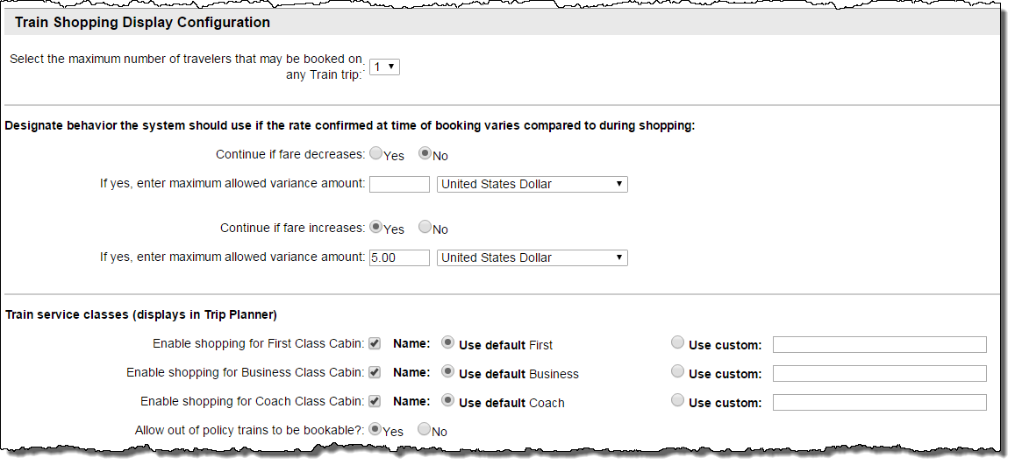
  - Select the maximum number of travelers that may be booked on any Train trip: Select 1 – 6 from the drop down list.
Note: At this time, 1 passenger can be supported.
  - Designate behavior the system should use if the rate confirmed at time of booking varies compared to during shopping:
    - Continue if fare decreases: Select the Yes or No radio button.
- If Yes, enter maximum allowed variance amount: Enter the number and select the currency from the drop down list.
    - Continue if fare increases: Select the Yes or No radio button.
- If Yes, enter maximum allowed variance amount: Enter the number and select the currency from the drop down list.
  - Train service classes (displays in Trip Planner):
    - Enable shopping for First Class Cabin: Select the checkbox to display this cabin class.
- Use default First: Select the radio button to use the term First when displaying this cabin class, or select the Use custom radio button to use the value entered in the field.
    - Enable shopping for Business Class Cabin: Select the checkbox to display this cabin class.
- Use default Business: Select the radio button to use the term Business when displaying this cabin class, or select the Use custom radio button to use a different term for this cabin class.
    - Enable shopping for Coach Class Cabin: Select the checkbox to display this cabin class.
- Use default Coach: Select the radio button to use the term Coach when displaying this cabin class, or select the Use custom radio button to use a different term for this cabin class.
  - Out of policy trains to be bookable?: Selecting Yes makes out of policy trains selectable (they will still be called out of policy) and selecting No will not allow the selection of out of policy trains.
- Hotel Shopping Display Configuration:
  - How you want to display Hotel results to your users:
    - Option 1: Preferred and non-preferred Hotels are displayed together. (End users will see all the properties at once. Preferred properties are automatically displayed first).
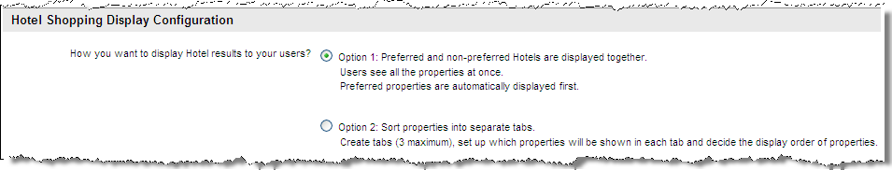
    - Option 2: Sort properties into tabs (a 3 tab maximum). Name the tabs and depending on the mode of preference upload, the properties will be displayed in each tab. (End users will see properties on up to 3 tabs based on site preferences).
Note: Click the Hotel Type Definition link to view more detail. Click Close Window to return.
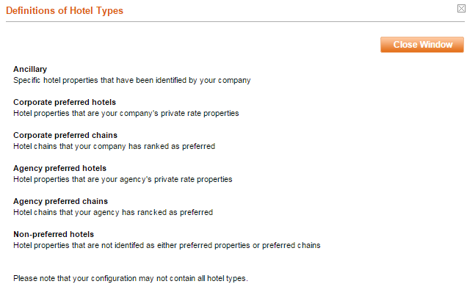
1 – How many tabs do you want? Select the 1, 2 or 3 radio button.
2 – Label the tabs with something your users will understand. They will see the tab labels when making their hotel selections.
3 – Check the boxes to select the hotel types for each tab.
- The order of properties can be rearranged later and are shown by using the hotels dropdowns on the left.
- It is recommended at least one tab include "Non-preferred Hotels."
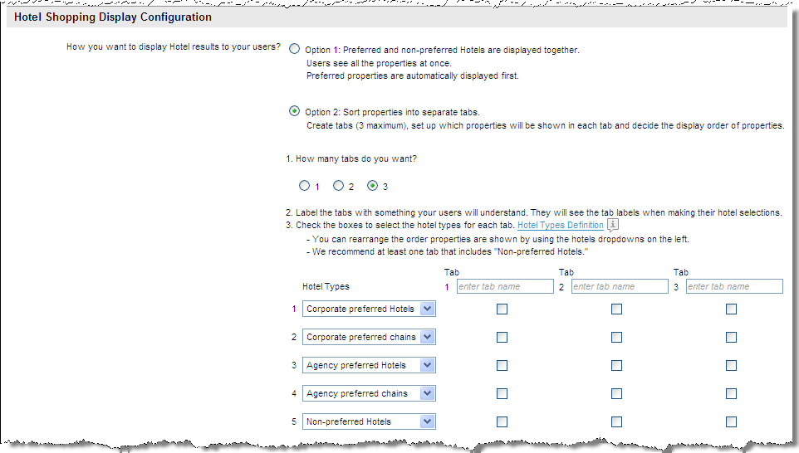
- Agency Preferred Hotels: These hotels are loaded either using a manual or automated feed by special arrangement with Deem.
- Agency Preferred Chains: These hotels are loaded at the Super Domain level into the Partner Dashboard | Configuration | Hotel Chain Vendor Preferences by a site administrator with super domain access.
- Corporate Preferred Hotels: These hotels are loaded at the site level using the Private Rates Template found at Partner Dashboard | Services tab | Travel | Private Rates by a site administrator with site access.
- Corporate Preferred Chains: These hotels are loaded at the site level using hotel chain preferences found within the site at Partner Dashboard | Services tab | Travel | Vendor Management | Hotel Chain Preferences by a site administrator with site access.
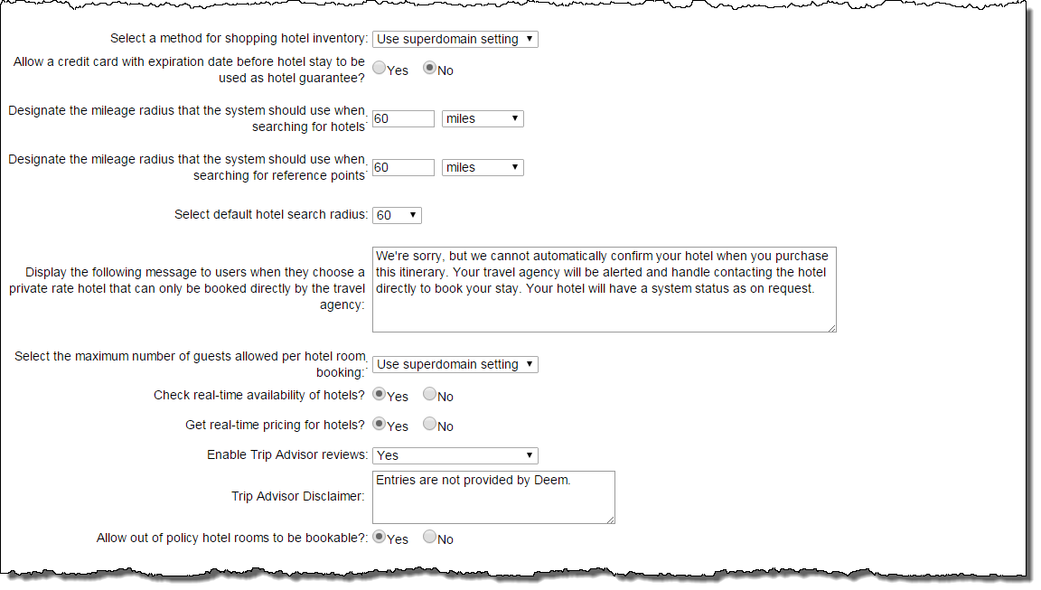
  - Select a method for shopping hotel inventory: Select Use superdomain setting, Both GDS and Ancillary, GDS or Ancillary from the drop down list.
  - Allow a credit card with expiration date before hotel stay to be used as hotel guarantee: Yes or No. Set to Yes will allow the use for hotel late arrival guarantee of a credit card that has an expiration date before the anticipated hotel stay.
  - Designate the mileage radius that the system should use when searching for hotels: Enter the number of miles away from the searched for hotel city that alternative hotel cities will be displayed. Also select the unit of measure to use when displaying the distance. It is recommended that 60 – 75 miles be used to limit the number of returned hotels.
  - Designate the mileage radius that the system should use when searching for reference points: Enter the number of miles away from the searched for reference point that alternative reference points will be displayed. Also select the unit of measure to use when displaying the distance. It is recommended that 60 – 75 miles be used to limit the number of returned reference points.
  - Select default hotel search radius: Select the number to use as the default search radius from the drop down list. The list will include the radius entered in Designate the mileage radius that the system should use when searching for hotels.
  - Display the following message to users when they choose a private rate hotel that can only be booked directly by the travel agency: Enter in text that will be displayed to the traveler if the selected hotel can only be booked directly by the travel agency. Be sure not to include travel lingo or HTML code since this message is displayed to the traveler.
  - Check real-time availability of hotels? Yes or No.
  - Get real-time pricing for hotels? Yes or No.
  - Enable Trip Advisor reviews: Select Use superdomain setting, Yes or No from the drop down list
  - Trip Advisor disclaimer: Enter up to 500 characters of HTML or plain text to display at the bottom of the list of comments travelers have provided for the property. This typically would be “The comments made by travelers do not reflect the company’s views” or something similar.
  - Out of policy hotel rooms to be bookable?: Selecting Yes makes out of policy hotel rooms selectable (they will still be called out of policy) and selecting No will not allow the selection of out of policy hotel rooms.
- Car Shopping Display Configuration:
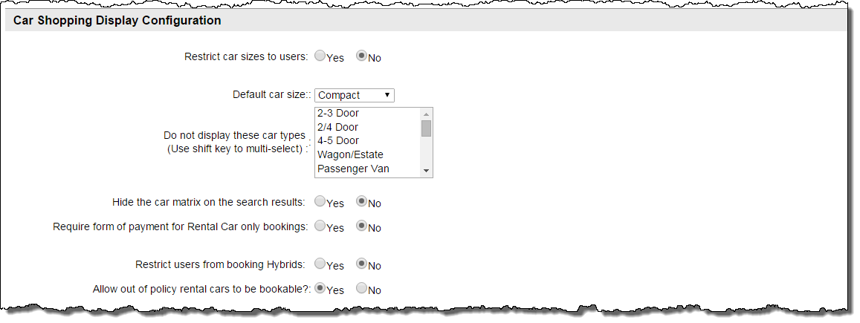
  - Restrict car sizes to users? Yes or No.
    - If Yes is selected:
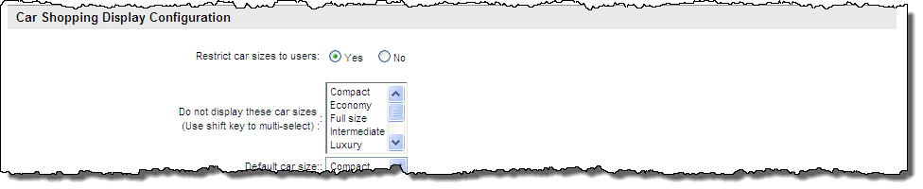
      - Do not display these car sizes: Select the car sizes to not display. Several can be selected by holding down the control key to select one at a time, or the shift key to select a range.
  - Hide the car matrix on the search results: Select the Yes or No radio button.
  - Require form of payment for Rental Car only bookings: Select the Yes or No radio button.
  - Restrict users from booking Hybrids: Select the Yes or No radio button.
  - Out of policy rental cars to be bookable?: Selecting Yes makes out of policy rental cars selectable (they will still be called out of policy) and selecting No will not allow the selection of out of policy rental cars.
- Booking, Change and Cancellation Configuration:
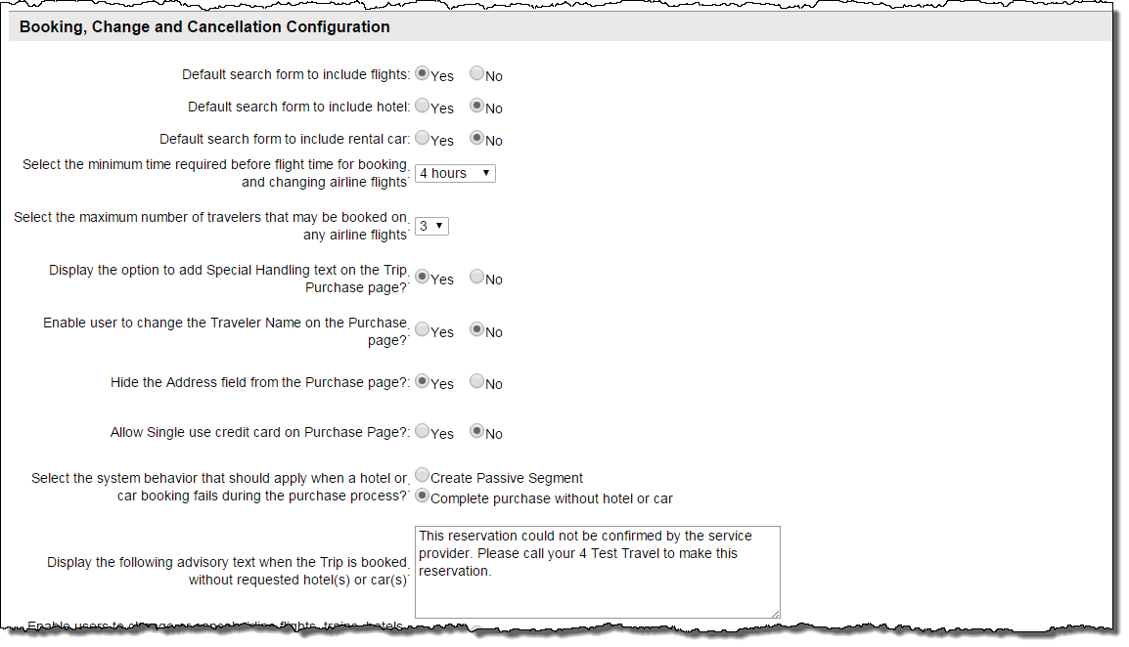
  - Default search form to include flights: Yes or No. Should the flight checkbox be pre-checked when the search form is presented to the traveler?
  - Default search form to include hotel: Yes or No. Should the hotel checkbox be pre-checked when the search form is presented to the traveler?
  - Default search form to include rental car: Yes or No. Should the rental car checkbox be pre-checked when the search form is presented to the traveler?
  - Select the minimum time required before flight time for booking and changing airline flights: Times range from No limit to 1 day in hour increments and 1 – 5 days in day increments.
  - Select the maximum number of travelers that may be booked on any trip: It is recommended that this be set to 1.
  - Display the option to add Special Handling text on the Trip Purchase page: Yes or No. Setting this to Yes will allow free form text to be entered by the traveler which can be used to set queue delivery options.
  - Enable user to change the Traveler Name on the Purchase page: Yes or No. It is recommended this be set to No, but can be used for non-profiled bookings such as for guest travelers.
  - Hide the Address field from the Purchase page: Yes or No. Selection of “No” will display the travelers address as listed in the profile. Yes will not display the address.
  - Allow Single use credit card on Purchase Page: Yes or No. Allow user to enter a one-time only form of payment on the Purchase Page. This card will not be saved to the user’s profile.
  - Select the system behavior that should apply when a hotel or car booking fails during the purchase process: Create a Passive Segment or Complete purchase without hotel or car.
Note: Rental car passive segments are no longer generated during booking flows as a default error response. Deem has implemented extensive retry and error handling for rental cars at purchase to avoid generating passive rental car segments.
The Display Configuration page in the dashboard will be modified in a future release to remove the word ‘car’ from this option.
  - Display the following advisory text when the Trip is booked without requested hotel(s) or car(s): Enter in text that will be displayed to the traveler if the trip is booked without the requested hotel or car. Be sure not to include travel lingo or HTML code since this message is displayed to the traveler.
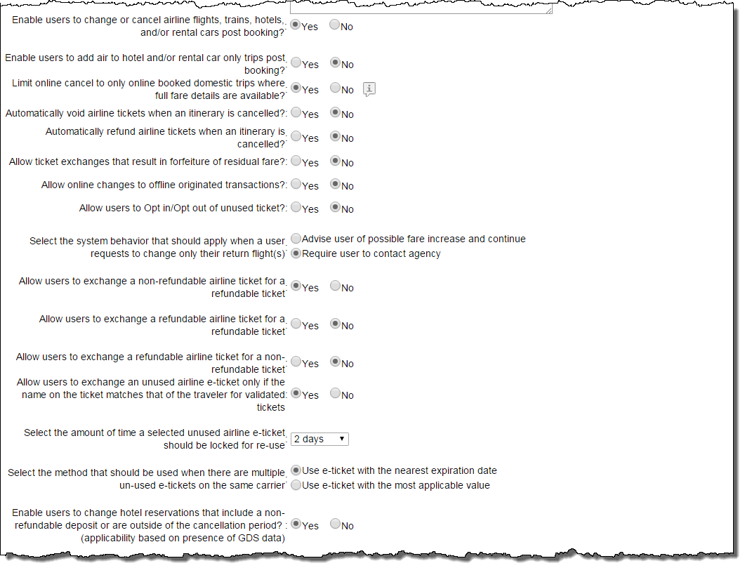
  - Enable users to change or cancel airline flights, hotels, and/or rental cars post booking? Yes or No. Selection to change or cancel air OR hotel OR rental car cannot be made. Only selection to change or cancel air AND hotel AND rental car can be made. Selecting Yes enables the storing of the unused ticket.
Note: Selecting No will hide the remaining fields in this section. Selecting Yes displays the following fields:
  - Enable users to add air to hotel and / or rental car only trips post booking: Yes or No.
  - Limit online cancel to only online booked domestic trips where full fare details are available: Yes or No.
  - Automatically void tickets when an itinerary is cancelled: Yes or No.
  - Automatically refund tickets when an itinerary is cancelled: Yes or No.
  - Allow ticket exchanges that result in forfeiture of residual fare: Yes or No. If Yes is selected an additional option is available:
  - Maximum value that the fare forfeiture will be allowed during an exchange: Enter a value.
  - Allow online changes to offline originated transactions? Yes or No.
  - Allow users to opt out of unused ticket? Yes or No.
  - Select the system behavior that should apply when a user requests to change only their return flight(s): Select either Advise user of possible fare increase and continue or Require user to contact agency
  - Allow users to exchange a non-refundable ticket for a refundable ticket: Yes or No.
  - Allow users to exchange a refundable ticket for a refundable ticket: Yes or No.
  - Allow users to exchange a refundable ticket for a non-refundable ticket: Yes or No.
  - Allow users to exchange an unused airline e-ticket only if the name on the ticket matches that of the traveler. Yes or No.
  - Select the amount of time a selected unused e-ticket should be locked for re-use: Select between 1 – 23 hours or 1 – 5 days. Recommended to be set to whatever is appropriate to the mid-office process.
  - Select the method that should be used when there are multiple unused e-tickets on the same carrier: Select either Use e-ticket with the nearest expiration date or Use e-ticket with the most applicable value.
  - Enable users to change hotel reservations that include a non-refundable deposit or are outside of the cancellation period (applicability based on presence of GDS data): Yes or No.
- Tentative Trips Configuration:
Note: Tentative trips can also be called “Held” trips.
  - Do you permit travelers to hold tentative trips? Yes or No. If No is selected:
  - Do you permit travelers to hold tentative trips? Yes or No. If Yes is selected:
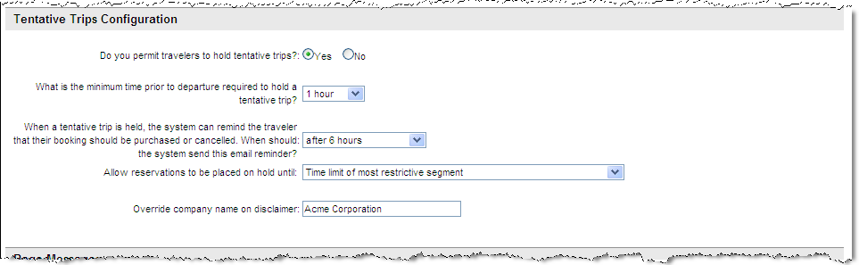
    - What is the minimum time prior to departure required to hold a tentative trip? Times range from 1 to 12 hours, and 24, 36, 48, 60, and 72 hours. This is typically set to 6 or 12 hours.
    - When a tentative trip is held, the system can remind the traveler that their booking should be purchased or cancelled. When should the system send this email reminder: Choose to not send a reminder or select After 6, 12, 24 or 48 hours.
    - Allow reservations to be placed on hold until: Time limit of most restrictive segment, 24 hours or time limit of most restrictive segment, whichever is earlier, or 48 hours or time limit of most restrictive segment, whichever is earlier
  - Override company name on disclaimer: Enter a name other than the agency name to display on the travel disclaimer, if appropriate. This could be the client name, for example.
- Page Messages:
Note: Configuration Team can assist with these messages.
Each of these messages allows up to 4000 characters, but it is suggested a limit for each message be no more than 400 characters for easier review by the traveler.
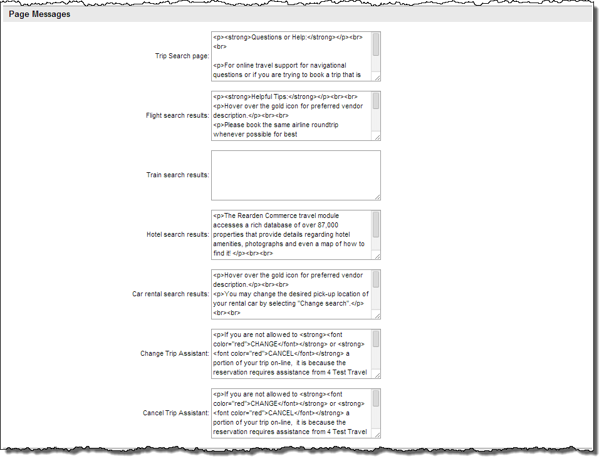
  - Trip Search page: Enter the HTML for a message that will display on the trip search page.
  - Flight search results: Enter the HTML for a message that will display on the flight search results page.
  - Hotel search results: Enter the HTML for a message that will display on the hotel search results page.
  - Car rental search results: Enter the HTML for a message that will display on the rental car search results page.
  - Change Trip Assistant: Enter the HTML for a message that will display on the change trip assistant.
  - Cancel Trip Assistant: Enter the HTML for a message that will display on the cancel trip assistant.
- If WebFare has been enabled, additional fields are available:
- WebFare Source Messages:
Note: Configuration Team can assist with these messages.
Each of these messages allows up to 4000 characters, but it is suggested a limit for each message be no more than 400 characters for easier review by the traveler.
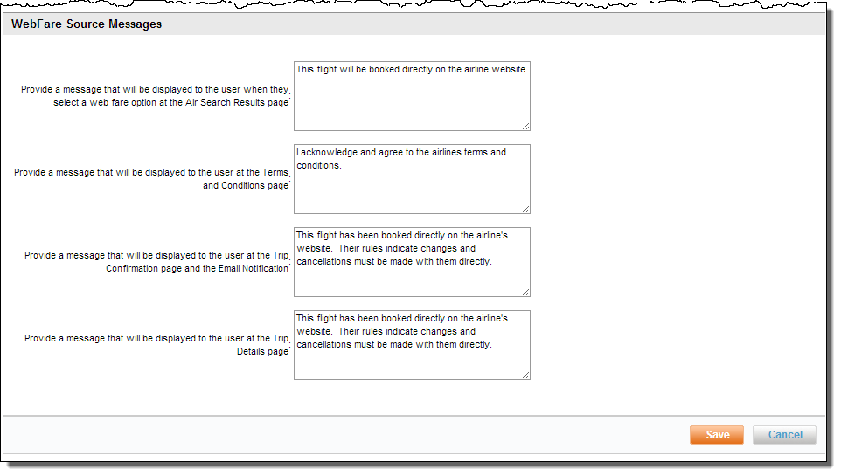
  - Provide a message that will be displayed to the user when they select a web fare option at the Air Search Results page: Enter the HTML for a message that will display on the air search results page.
  - Provide a message that will be displayed to the user at the Terms and Conditions page: Enter the HTML for a message that will display on the Terms and Conditions page.
  - Provide a message that will be displayed to the user at the Trip Confirmation page and the Email Notification: Enter the HTML for a message that will display on the Trip Confirmation page and be included in the Trip Confirmation email.
  - Provide a message that will be displayed to the user at the Trip Details page: Enter the HTML for a message that will display on the Trip Details page.
- Click Save to save your changes.

Display Configuration Sets
- Add the List to a Set as previously discussed.
- Click the “_ changes not applied” link to commit the changes. The changes made since the last time a commit was done are displayed. Click the Commit button to commit the changes to the database.

Custom Fields
Custom fields are used when agencies require data that is not already being collected by Deem to support either specialized booking or profile requirements. Custom fields can be created using the Deem customizable profile field tool if the field will be used for reporting or by creating a new, custom field if the field is needed for booking or purchase page display.
When a site is cloned from a template, any custom fields found on the template will be created on the cloned site.
Note: Custom fields are not reportable in our standard reports.
Note: Custom fields cannot be used as a Group Parameter.
- Click the Services tab then the Travel link in the Travel section of the page.
- The Services / Travel page is displayed. Click the Custom Field Configuration link.
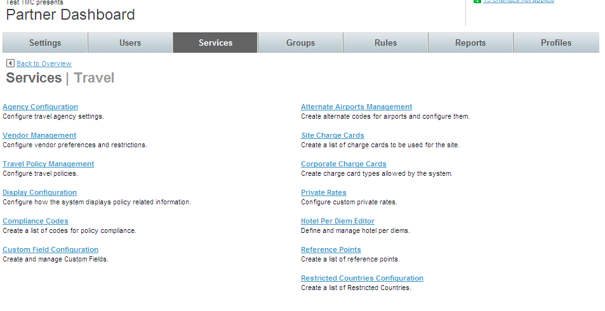
- The Services | Custom Field Configuration page is displayed. Click the Custom Field Collections link.
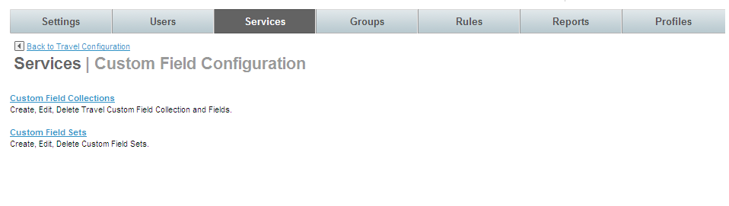

Custom Field Collections
Note: Custom fields use the List and Set structure. Think of the Collection as the List with an additional layer below it for the custom field definition itself. To create and implement custom fields, first create the collection and add custom fields to it then the collection is added to a Set. The set is attached to Service Rules to define what groups of users will see the custom fields.
- The Services | Custom Field Collections page is displayed.
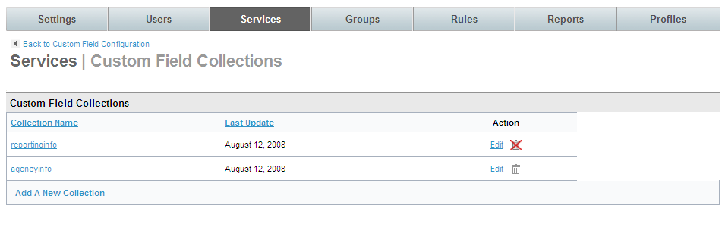
- Click the Add A New Collection link to add a new custom field. The Services | Add page is displayed. Complete the page:
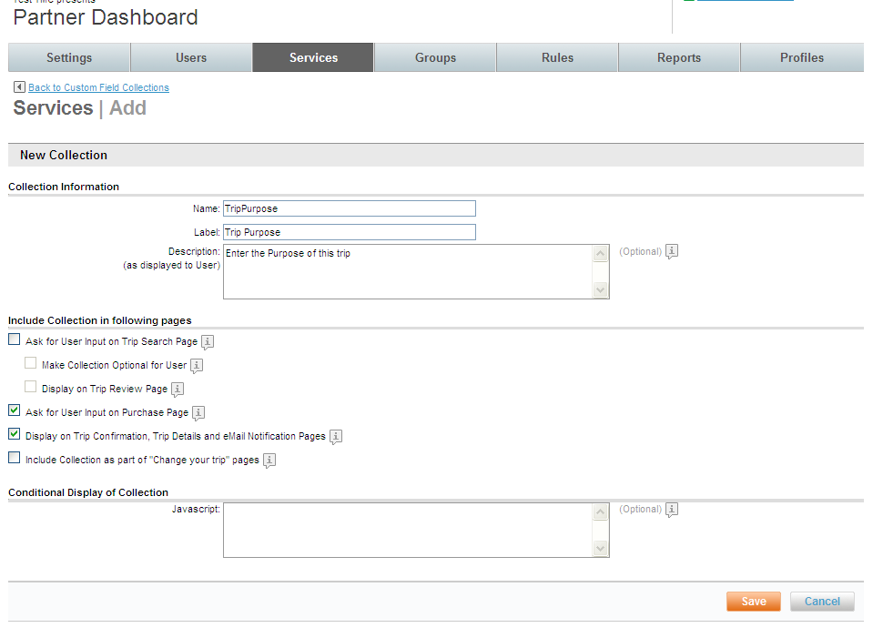
- New Collection:
  - Name: Name the collection. This is the name the database will use in reference to this collection. The name cannot include any spaces and has a maximum length of 128 characters. The value can be alphanumeric, but the first character must be an alpha character. The collection name must be unique and is case sensitive.
  - Label: Enter the label that will be displayed to the user as a header on the box that lists custom fields.
  - Description: (as displayed to User): This field will be displayed to the user as text within the box that lists custom fields.
- Include Collection in following pages:
  - Ask for User Input on Trip Search Page: By selecting this checkbox, the user will see the custom field on the Trip Search page.
    - Make Collection Optional for User: By selecting this checkbox, custom field will be required on the Trip Search page.
    - Display on Trip Review Page: By selecting this checkbox, the user will see (but not be able to edit) the custom field on the Trip Review page. It is recommended that if the field is displayed on the Trip Search page, it be shown on the Review page as well.
  - Ask for User Input on Purchase Page: By selecting this checkbox, the user will see the custom field on the Trip Purchase page.
  - Display on Trip Confirmation, Trip Details and eMail Notification Pages: By selecting this checkbox, the user will see the custom field on the Trip Confirmation, Trip Details and eMail Notification Pages.
  - Include Collection as part of “Change your trip” pages: By selecting this checkbox, the user will see the custom field on “Change your trip” pages.
- Conditional Display of Collection:
  - JavaScript: By entering JavaScript, set conditions for which the custom field will be displayed or not. An example is that if the arrival city is Miami, display a custom field. For any other arrival city, the custom field would not be displayed.
Note: Enter a ticket if assistance from the Deem Configuration Team is needed with the JavaScript modification.
- Click Save to save the custom field collection. The Services | Custom Field Collections page is redisplayed. Click the Collection Name link to add fields to it.
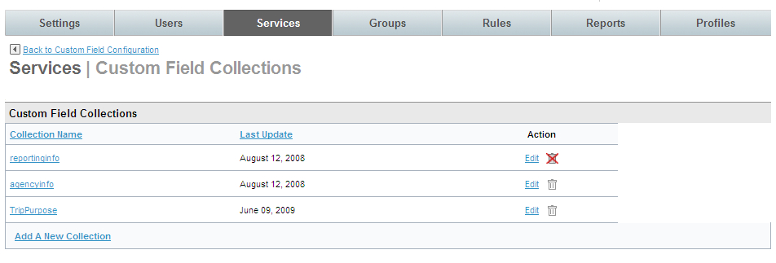
- The Custom Fields page is displayed. Click the Add Custom Field link.
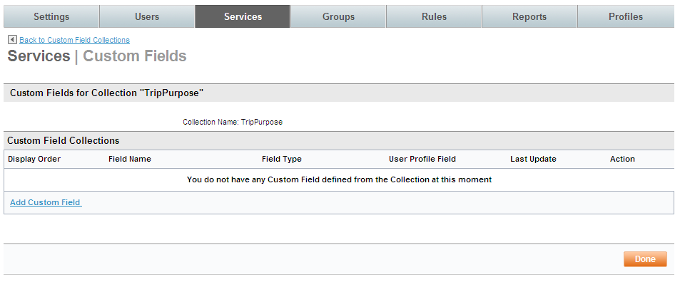
- The Services | Add page is displayed. Complete the page:
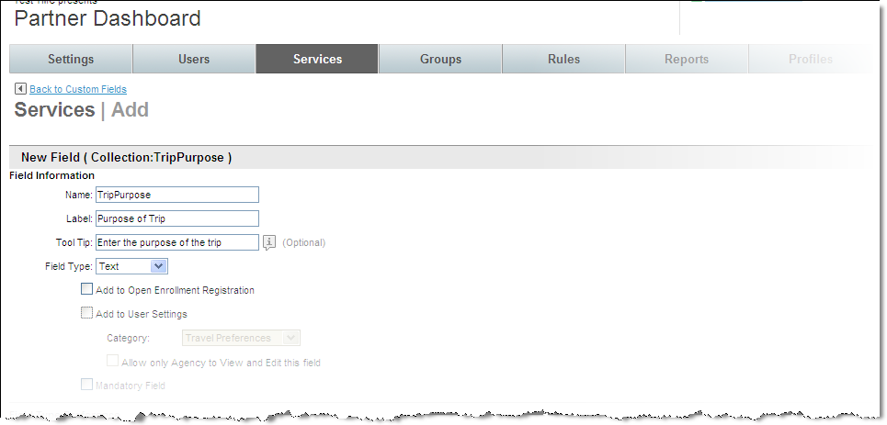
- New Field (within Collection:name):
  - Field Information:
    - Name: Enter a name for this custom field. This is the name the database will use in reference to this field.
Note: Any changes to the field name once it is saved will result in the need for programming changes. The name cannot include any spaces and has a maximum length of 128 characters. This field can be alphanumeric, but the first character must be an alpha character. The field name must be unique and is case sensitive.
    - Label: Enter the label that will be displayed to the user
    - Tool Tip: Enter a tip that can be displayed to the user
    - Field Type: Select Text, Checkbox, Date/Time, Number, List or PTA from the drop down list.
Important Note: Once the field has been saved, the field type cannot be changed.
Note: PTA will appear if Pre-trip Approval has been enabled. PTA is discussed in other documentation.
Note: Field Type Preference will differ depending on the selection made to Field Type.
    - Add to Open Enrollment Registration: Select this checkbox if the field is to appear in open enrollment registration.
    - Add to User Settings: Select this checkbox if the field is to appear in user settings.
- Category: Select the user setting Personal Information, Contact Information, Employee Information, Business Address, Home Address, Emergency Contact or Travel Preferences from the drop down list.
- Allow only Agency to View and Edit this field: Select this checkbox if only agency users can see or change this field.
    - Mandatory Field: Select this checkbox if the field will be required
Note: Field Type Preference will differ depending on the selection made for Field Type.
  - Field Type Preference – Text
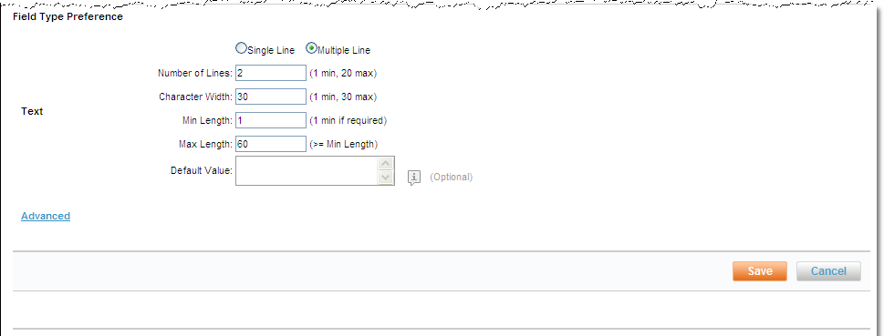
    - Single Line / Multiple Lines: Select if the text field will allow single or multiple line entry.
    - Number of Lines: If Multiple Line was selected, how many text lines can be entered – minimum is 1 and maximum is 20 lines.
    - Character Width: This is set to 30. This represents the number of characters allowed in the text box before a carriage return would occur.
    - Min Length: Enter the minimum allowable length for the entire field with a minimum of 1 if the field is required.
    - Max Length: Enter the maximum allowable length for the entire field with a maximum of at least greater than the minimum.
    - Default Value: Enter the value to display as a default.
An example of this would be if the traveler has any special requirements while traveling. The “Special Requirements” text box would be displayed on the user profile.
  - Field Type Preference – Checkbox
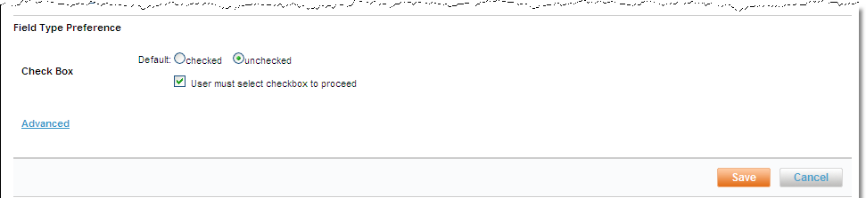
    - Default: Select either Checked or Unchecked as the default for the checkbox.
    - User must select checkbox to proceed: Before a user can move on in the application, the checkbox must be marked. It is recommended the checkbox be unchecked as the default.
An example of this would be if Terms and Conditions have been presented. The “I Accept” or “I Do Not Accept” checkbox would have to be selected before the user could leave the page.
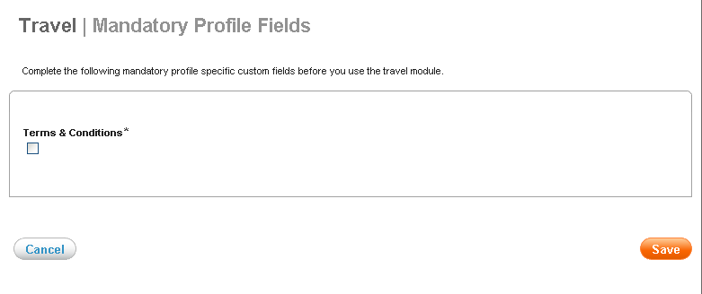
  - Field Type Preference – Date / Time
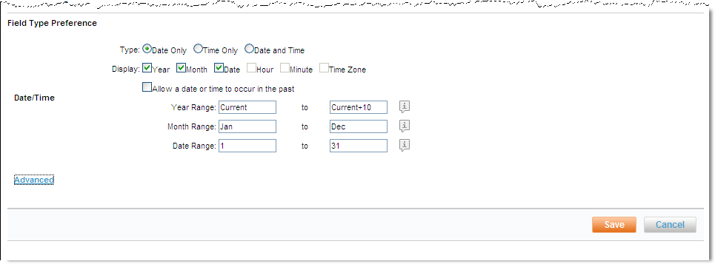
    - Type: Select Date only, Time only, or Date and time from the drop down list.
    - Display: Select Year, Month, Date Hour Minute, and / or Time Zone checkboxes as appropriate.
    - Allow a date or time to occur in the past: Select this checkbox if past dates or times will be allowed.
    - Year Range: Enter the beginning and ending year range allowed. Use Current to begin the range with the current year and Current+X to say how many years in the future the date entered can be. Current+5 will be this year plus 5 years.
    - Month Range: Enter the beginning and ending month. Generally, Jan and Dec are entered
    - Date Range: Enter the beginning and ending date range allowed. Generally, 1 and 31 are used.
  - Field Type Preference – Number
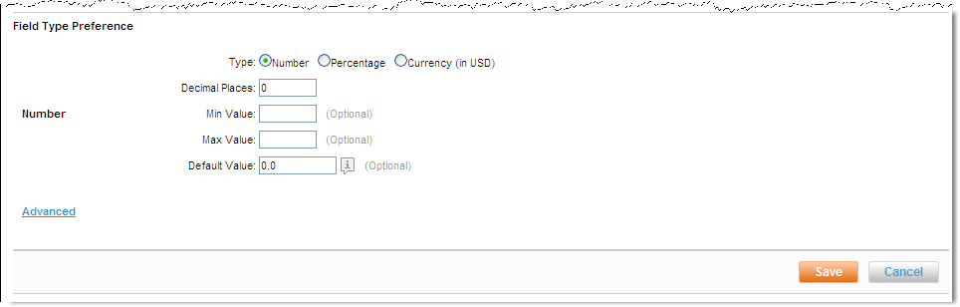
    - Type: Select Number, Percentage, or Currency from the drop down list.
    - Decimal places: Enter the number of decimal places.
    - Min Value: Enter the minimum value allowed in this field.
    - Max Value: Enter the maximum value allowed in this field. If the field is to be sent to the GDS during profile synchronization, the maximum value (not number of characters) must be less than 30. Maximum number of characters is 8.
    - Default Value: Enter the value to display as a default.
An example of this would be the employee’s Cost Center.
  - Field Type Preference – List
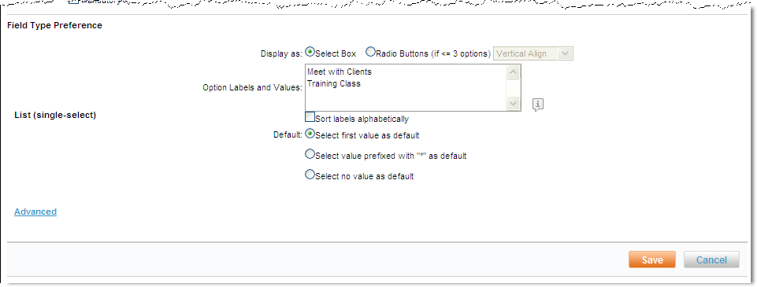
    - Display as: Select Select Box or Radio Buttons from the drop down list.
    - Option Labels and Values: Enter the labels which will be displayed to the user and the value that will be placed in the record separated by an equal sign. Example: “Cost Center=CC”. Generally, “Select no value as default” is selected.
An example of this would be the Employee Type.
- Click Save to save the Custom Field and Done.
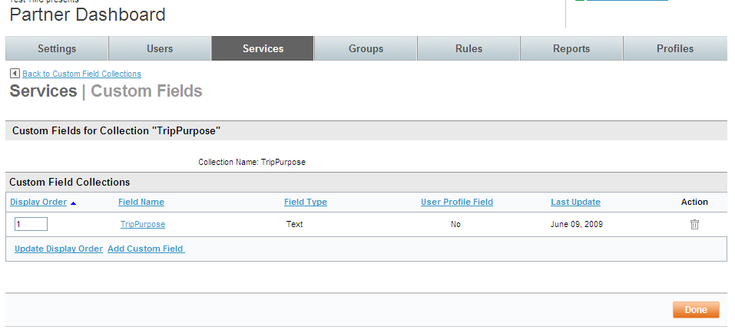
- The Services | Custom Field Collections page is redisplayed. Enter a display order and click the Update Display Order to rearrange the order of the custom fields within the collection. Click the Add Custom Field link to add additional custom fields to this Collection or click Done to return to the Services | Custom Field Collections page.

Custom Fields Sets
- Next we will add the Collection to a Set. Click the Back to Custom Field Configurations link at the top of the page. The Services | Custom Field Configuration page is displayed.
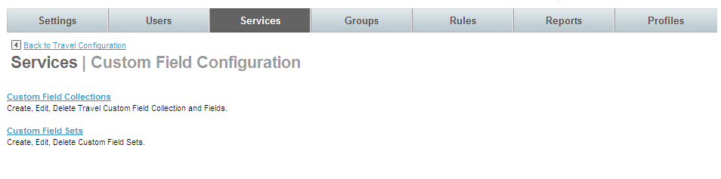
- Click the Custom Field Sets link. The Services | Custom Field Sets page is displayed.
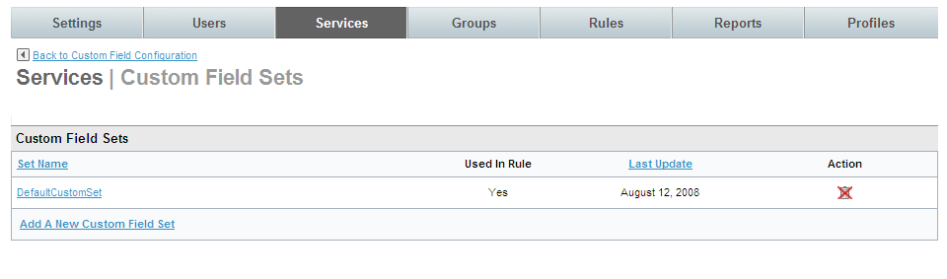
- Click Add A New Custom Field Set link. The Services | Add page is displayed.
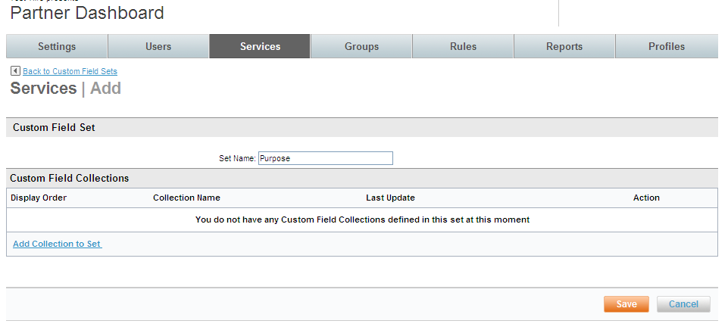
- Enter a Set Name for the Set and click Add Collection to Set link. The Services | Add Custom Field Collection page is displayed.
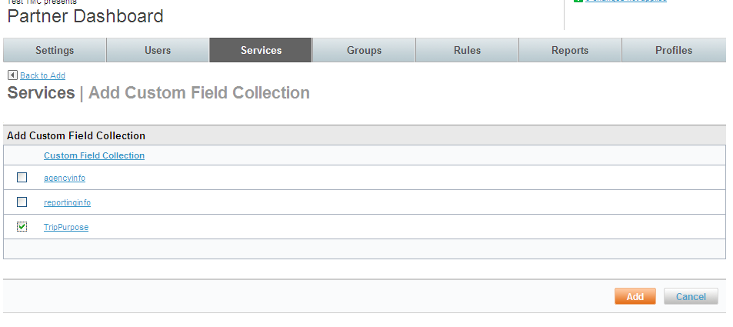
- Select the radio button beside the Custom Field Collections one at a time to add them to this set. Click Add. The Services | Add page is redisplayed.
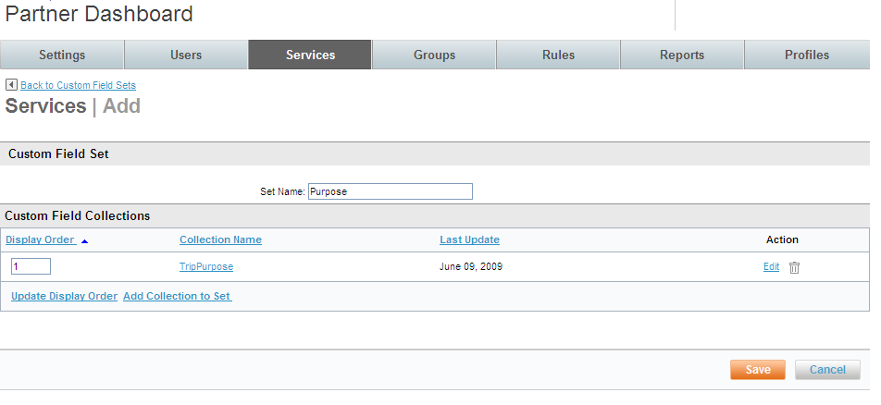
- Click Save to save the configuration. The Services | Custom Field Sets page is redisplayed.

Restricted Countries
Restricted countries are countries to which travel is either not allowed or if travel is requested, warning messages are displayed.
When a site is cloned from a template, any restricted countries defined on the template will be created on the cloned site.
Configuration can be performed on the Super Domain level to govern all sites within a Domain Group or on the site level for more individual configuration. In most cases, if restricting countries is done on the super domain level, it will have been configured during the implementation process.

Restricted Countries at the Super Domain Level
To configure restricted countries on the Super Domain level:
- Sign into the Partner Dashboard with an ID and Password with Super Domain permissions. Click the Configuration tab then the Manage Restricted Countries Lists link.
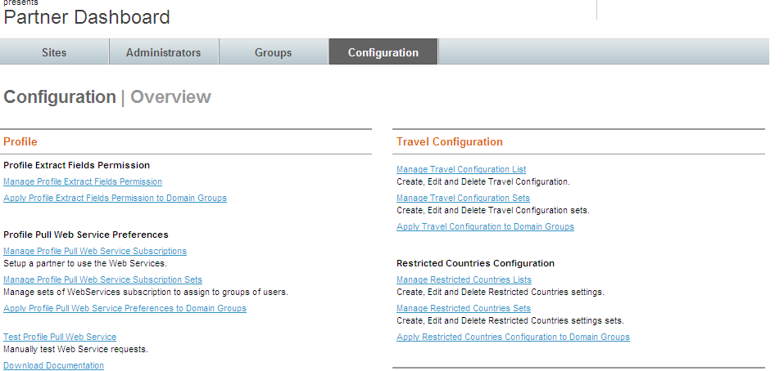
- The Configuration | Restricted Countries Lists page is displayed. Click the Add Restricted Countries Configuration link.
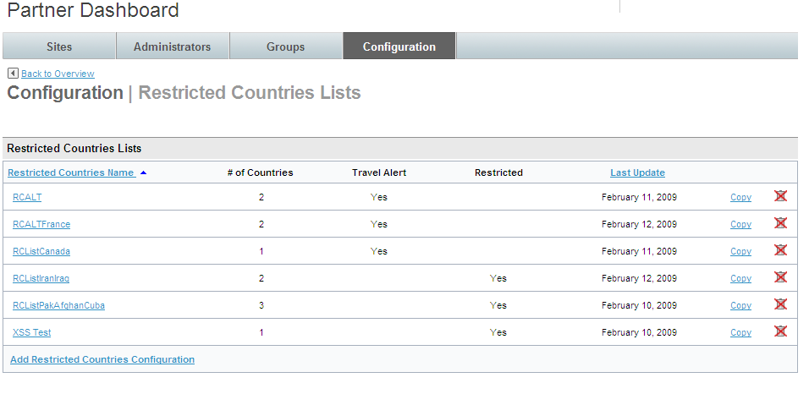
- The Configuration | Edit page is displayed.
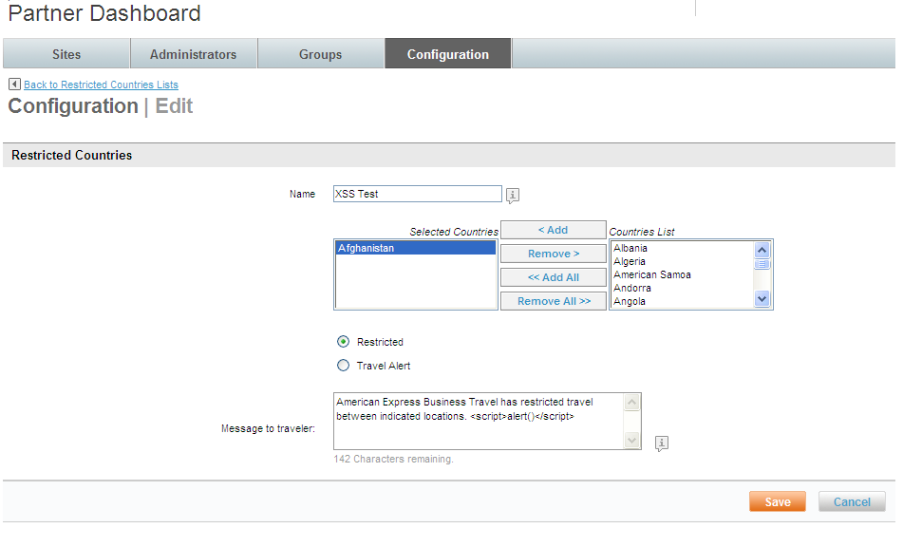
- Complete the page:
- Name: Name the configuration
- Select Countries from the Countries List and click the Add button to add them to the Selected Countries box. More than one country may be selected by holding the control key.
- Restricted / Travel Alert radio buttons: Select either radio button to either not allow travel at all by selecting the Restricted button, or alerting travelers by selecting the Travel Alert button.
- Message to traveler: Enter a message to be displayed to the traveler if one of the restricted countries is used as a destination country.
- Click Save to save the configuration. Add the Restricted Countries List to a Set.
- Click the Apply Restricted Countries Configuration to Domain Group to add the Set to a group of Domains.

Restricted Countries at the Site Level
To configure restricted countries on the Site level:
- From the Super Domain, select the Sites tab and choose a site from the list.
- The Settings tab is displayed. Click the Services tab.
- The Services | Overview page is displayed. Click the Travel link in the Travel section of the page.
- The Service | Travel page is displayed. Select the Restricted Countries Configuration link.
- The Services | Restricted Countries Configuration Management page is displayed. Restricted countries follow the List and Set structure.
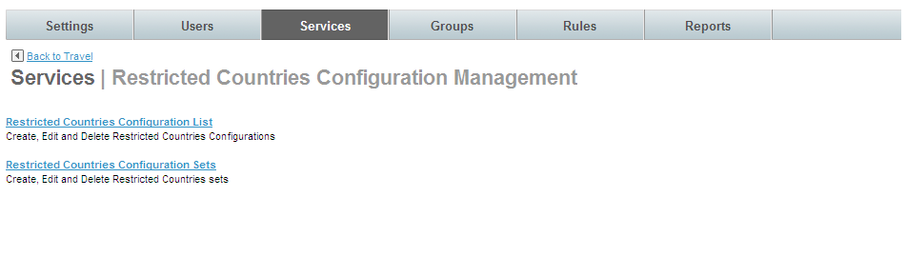
- Click the Restricted Countries Configuration List link. The Services | Restricted Countries Configuration List page is displayed. Click the Add Restricted Countries Configuration link to add a new configuration.
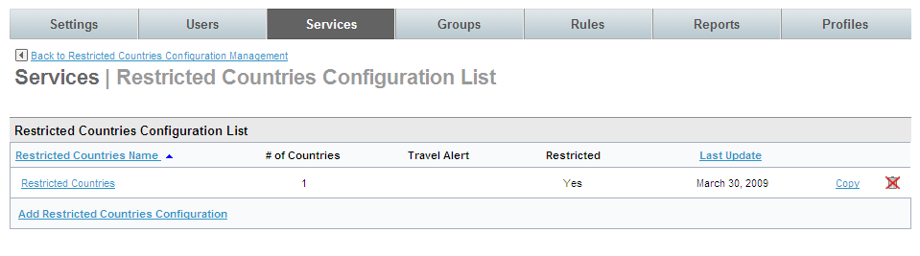
- The Services | Add page is displayed. Complete the page.
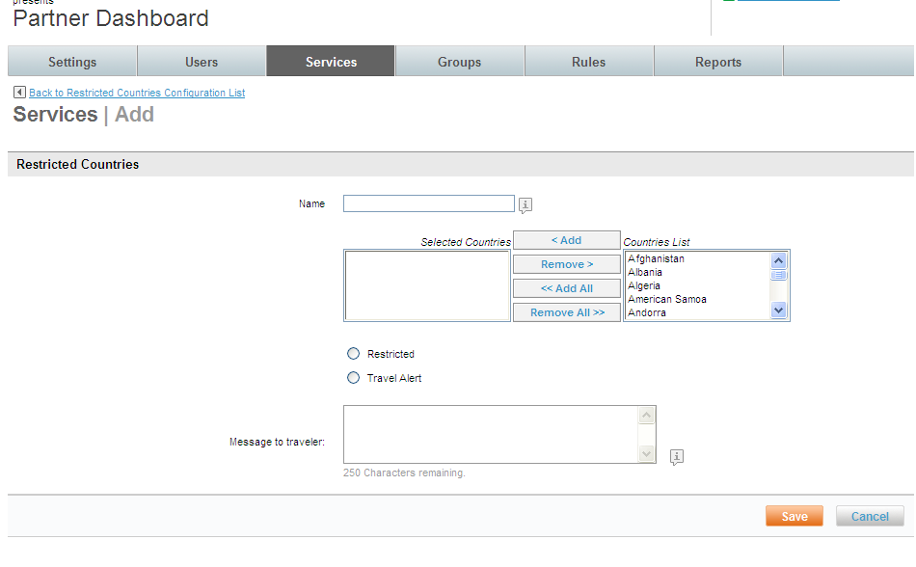
- Name: Name the configuration
- Select Countries from the Countries List and click the Add button to add them to the Selected Countries box. Select more than one country by holding the control key.
- Restricted / Travel Alert radio buttons: Select either radio button to either not allow travel at all by selecting the Restricted button, or alerting travelers by selecting the Travel Alert button.
- Message to traveler: Enter a message to be displayed to the traveler if one of the restricted countries is used as a destination country.
- Click Save to save the configuration. Add the Restricted Countries List to a Set.
- Add the Restricted Countries configuration to a Travel Rule for a group of travelers.

Restricted Country Examples
When a country is selected for travel that has been designated as Restricted, the traveler will see the below messaging:
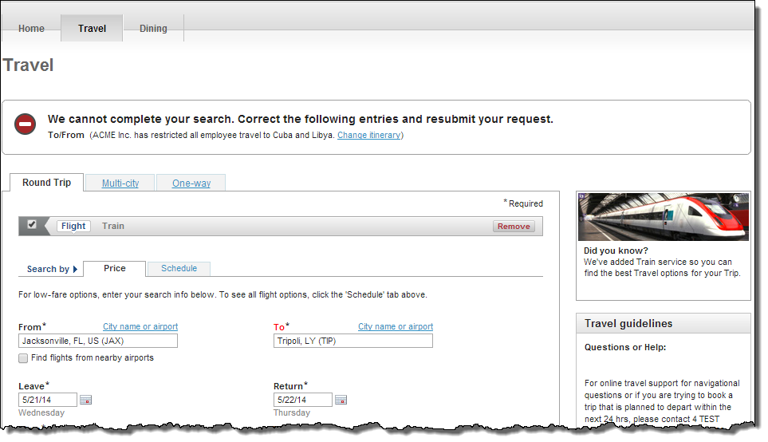
When a country is selected for travel that has been designated as requiring a Travel Alert, the traveler will see the below messaging:
