**NAME OF COMPANY HERE**

LOGO HERE

PREPARED & SUBMITTED, DATE HERE

NAME HERE

EMAIL HERE

PHONE HERE

**www.deem.com**



**642 Harrison St. Floor 2**  
San Francisco CA 94107

**Deem Work Fource: Saving you time & money**

The most difficult part of a business trip is too often the trip itself. At Deem, we spend a lot of time figuring out ways to save you time and money. When you travel, our job is to make your job easier. When you manage your travelers, we’ve got the solutions you need. When you want to grow your business, we’re right there with you. With 50,000 corporate customers and the world’s largest travel management companies on the Deem platform, we’ve got you covered.

**Deem Work Fource**

Deem Work Fource is a suite of travel booking and management tools for the entire business travel ecosystem. Deem Work Fource brings beautiful design, machine learning and customization together to provide travelers, travel managers, TMCs and suppliers with a dynamic and seamless platform - all the way from shopping and booking to applying policy and managing costs.

“Deem balances the objectives of a company and what the traveler needs and wants”

- Steve Lee, Manager, Professional Travel Service

**Deem Feature Favorites**

Deem Work Fource is a full-feature business travel solution, but here are just a few of the traveler and travel manager favorites unique to Deem:



### **FREE 24-hour CHECK-IN**

Access to free 24-hour auto check-in on Southwest Airlines, guaranteeing a 90% placement in A + B boarding – travelers can choose an aisle or window seat and leave the middle seats for someone else!

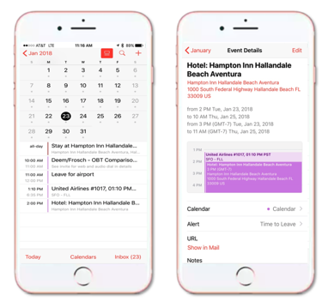

### **AUTOMATIC & DYNAMIC CALENDAR INTEGRATION**

Automatic and dynamic calendar entries are created with every travel booking - accessible online and offline, via mobile, sharable and connected to an address book. Fully integrated with Exchange Server, LDAP, iCal and Google Calendar.

### **GUIDED TRAINING AND HELP**



The integrated WalkMe feature guides travelers step-by-step through booking and managing their trips. Tailored for company policy and compliance, and available on request.



**DEEM FACEBOOK MESSENGER**

Deem Facebook Messenger is a mission-achieving, right-when-you-need-it problem solving chatbot assistant built seamlessly into the Facebook Messenger platform.

* **Industry-Leading User Experience:** Intuitive and dynamic, design across desktop and mobile. Easily search and compare air, hotel, rental car and car service options. Flexible policy filters and preferred supplier badges for easy reference. Access to TripAdvisor reviews and travel must-knows such as amenities, seat availability and on-time performance.
* **Google’s ITA Search Engine:** Unparalleled air fare search provides more options, in a shorter time frame than GDS-only-based solutions. Dynamic sorting allows travelers to find their preferred option quickly.

* **Branded and Flexible Fares:**   
  Travelers can easily view multiple fare categories, airline branded and promotional fares for each flight option, allowing them to compare prices and restrictions, and choose the fare with the best value and convenience.
* **Global Capabilities:**   
  Deem Work Fource includes a language editor (15 languages and counting), a content hub for accessing hundreds of low-cost carriers and rail options, and administrative tools that allow for easy configuration of local preferences.
* **Robust Policy Engine:**   
  Flexible, highly configurable, multi-level policy platform.
* **Mobile App:**   
  iPhone and Android apps provide travelers with an easy-to-use interface for booking and changing travel plans while on the go. Provides in-trip alerts and notifications to keep travelers informed. Is fully integrated with Deem Open Expense, enabling easy receipt capture and expense report management.
* **Dynamic Site Messaging:**   
  Set up customizable messaging based on individuals or groups. Messages can be assigned to content or for behavior, and are used to inform, influence and guide travelers, enabling better duty of care, policy compliance and overall travel experience.
* **Notification Engine:**   
  Automatic notification of flight changes and cancellations via text or voicemail.
* **Integrated Car Service:**   
  Ability to book ground transportation in-flow. Integrates with travel itinerary allowing for enhanced service levels and trackability.
* **Open Expense:**   
  Integrate travel and expense data into any external expense platform.
* **Automated Ticket Exchange:**   
  A powerful tool that completely automates the use of unused tickets.

# **Powerful mobile app**

View and search for upcoming flights from your phone, and book hotels and car service based on location, brand, policy, TripAdvisor ratings, or price. Stay informed and share details with real-time status updates via email, voice, and text.

## **Key capabilities**

* **Set policy**- Tailor travel policies and restrictions. We'll even help you set policies and restrictions if you don't have them in place.
* **Automated exchange**-Rebook, reuse or refund — our automated ticket exchange reduces your unused ticket liability seconds.
* **Approve in advance**-Unique pre-trip approval and notification workflow saves time and money.
* **Dynamic messaging**- Receive automated notifications about changes to itineraries.
* **Repeat bookings**- Easily replicate frequent trips and store your travel preferences to streamline future bookings.
* **Go mobile**- Search and book all your travel needs on the Deem mobile app.
* **Control messaging**- Create, change and delete custom messages to communicate certain travel policy or supplier related info.

# **Expense on the go**

With Deem Work Fource and Expense, employees get easy to use tools they need to book trips and submit expenses, while companies get increased control over suppliers, policy compliance and spend management – it’s a win-win.

## **Key capabilities**

* **Corporate Card Integration** - Seamless reconciliation with corporate feeds.
* **Intelligent Matching** - An algorithm that intelligently matches and merges travelers’ receipts with the corresponding credit card records.
* **Policy Engine** - Customize policy by segment and individual, set daily limits and cap occurrences by expense type. Notify travelers when out of policy.
* **Cost Allocation** - Allocate expenses to different cost segments (projects, locations customers etc.), using unlimited hierarchies, link with profile fields. Import cost segments using an upload file and set up automatic uploads.
* **Approval Permissions and Workflow** - Define cost-segment-based and multi-level approval workflow including pre and post, delegate and ad hoc approvers.

**Implementation**

A dedicated professional services team is available for your five-phased implementation setup.

## **Scheduled Phases**

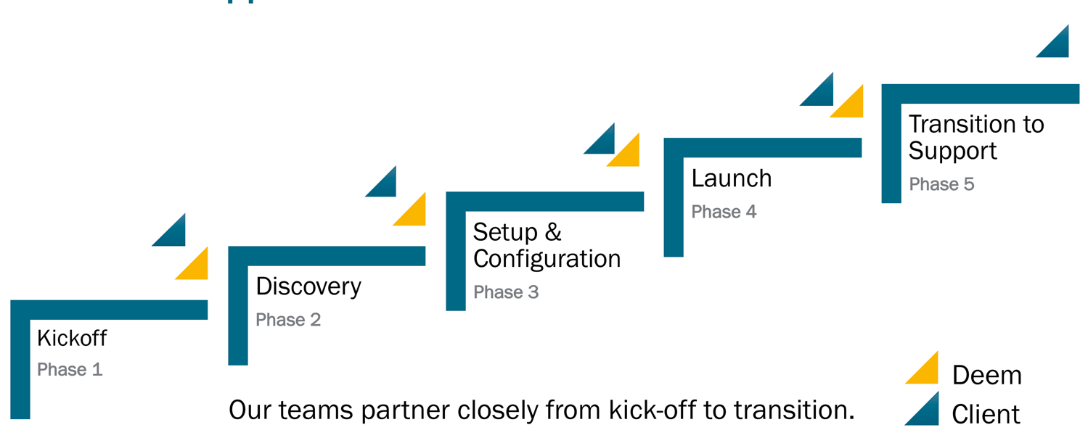

## **Implementation timeline**

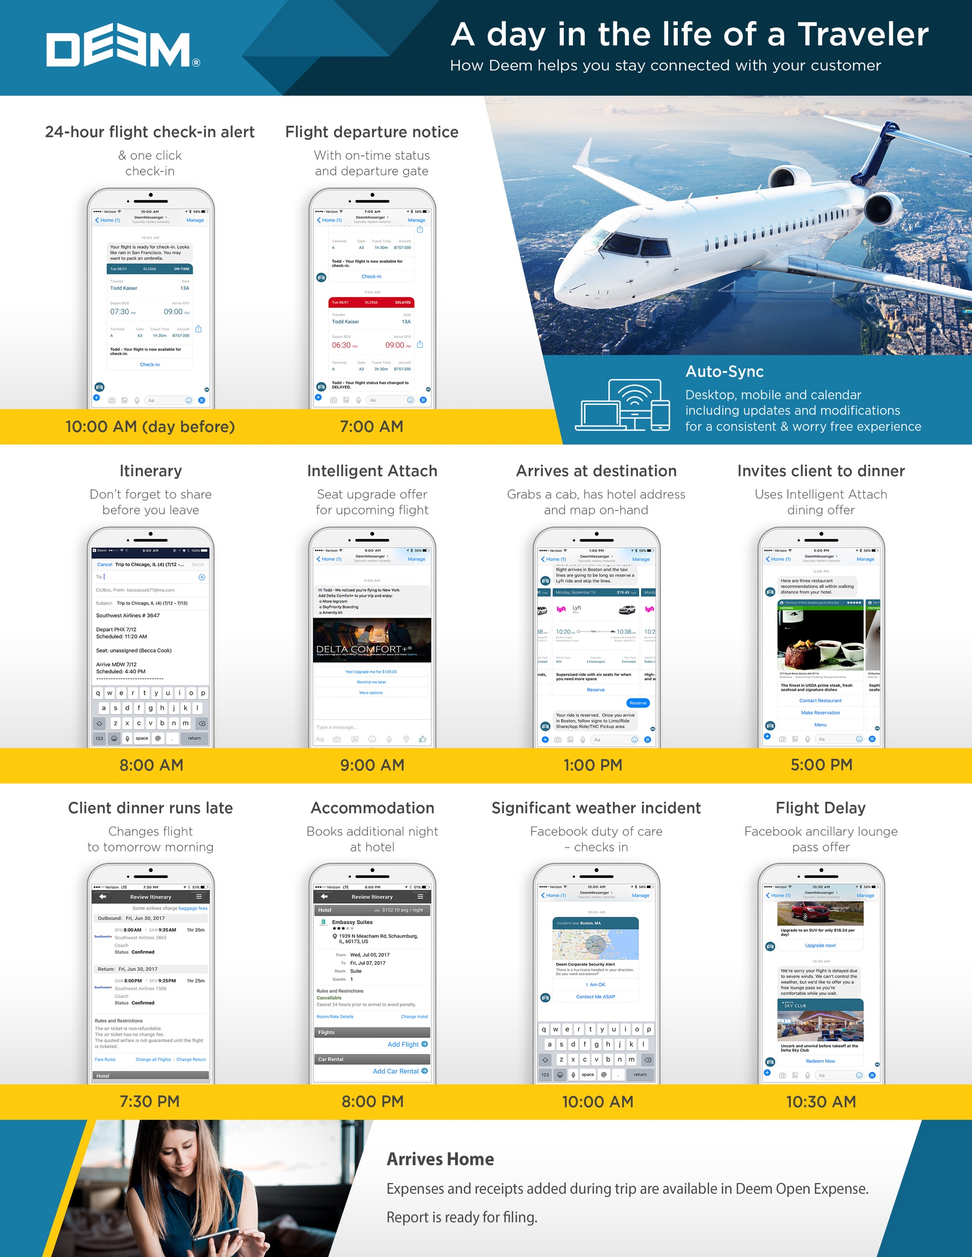

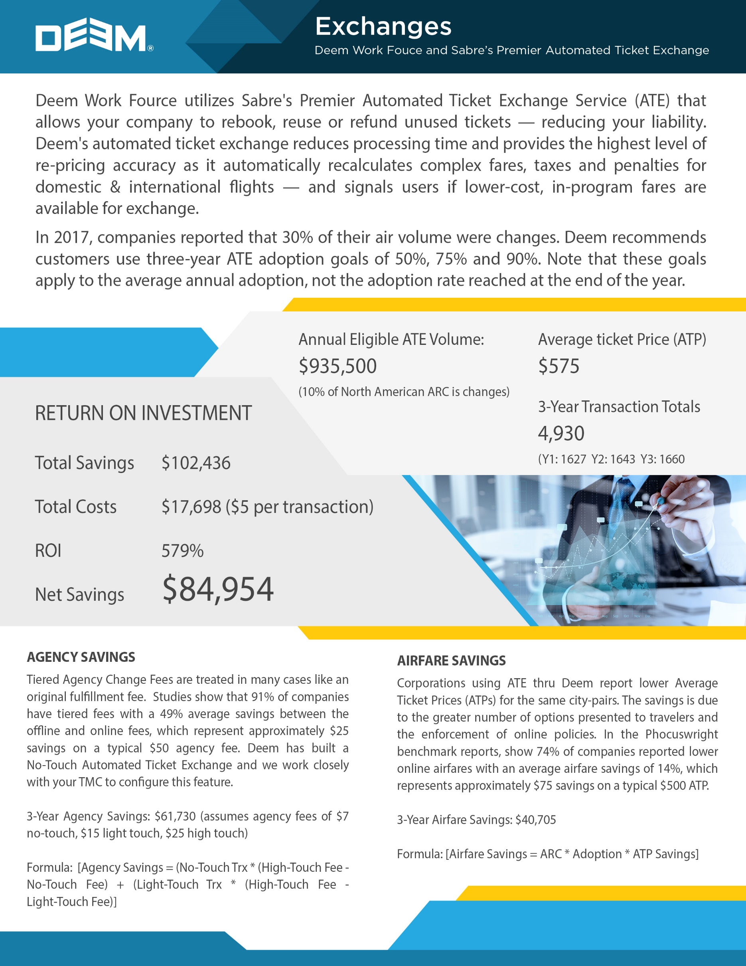

Annual Expense Reports

**ADD # HERE**

Average Expense Report Amount

**$XXXXX**

SAVINGS

MONTHLY: **$XXXXX**

ANNUAL: **$XXXXXX**

DEEM WORK FOURCE REPORTING

The Deem Work Fource platform provides travel managers and finance professionals with a suite of tools that help control travel spend, enforce company rules, simplify reimbursement and provide robust reporting and analytics. Deem Work Fource offers several ready-made reports with hover-over details, which can be run based on your designated date range. These reports can be exported in Excel, CSV or PDF. Custom reports are available, based on a statement-of-work (SOW), for a fee. The following are samples of reports you can generate (more screenshot samples can be viewed here: <https://deemadmin.atlassian.net/wiki/spaces/EN/pages/9961576/Report+Samples>):

[**Travel**](https://deemadmin.atlassian.net/wiki/spaces/EN/pages/9961576/Report+Samples#ReportSamples-Travel)

* [Airport Parking](https://deemadmin.atlassian.net/wiki/spaces/EN/pages/9961576/Report+Samples#ReportSamples-AirportParking)
* [Flight Cancellation](https://deemadmin.atlassian.net/wiki/spaces/EN/pages/9961576/Report+Samples#ReportSamples-FlightCancellation)
* [Hotel Details](https://deemadmin.atlassian.net/wiki/spaces/EN/pages/9961576/Report+Samples#ReportSamples-HotelDetails)
* [Rail Details](https://deemadmin.atlassian.net/wiki/spaces/EN/pages/9961576/Report+Samples#ReportSamples-RailDetails)
* [Unused Tickets](https://deemadmin.atlassian.net/wiki/spaces/EN/pages/9961576/Report+Samples#ReportSamples-UnusedTickets)
* [Pre-Trip Approval Detail](https://deemadmin.atlassian.net/wiki/spaces/EN/pages/9961576/Report+Samples#ReportSamples-Pre-TripApprovalDetail)

[**Expense**](https://deemadmin.atlassian.net/wiki/spaces/EN/pages/9961576/Report+Samples#ReportSamples-Expense)

* [Executive Summary](https://deemadmin.atlassian.net/wiki/spaces/EN/pages/9961576/Report+Samples#ReportSamples-ExecutiveSummary)
* [Department Spend Detail](https://deemadmin.atlassian.net/wiki/spaces/EN/pages/9961576/Report+Samples#ReportSamples-DepartmentSpendDetail)
* [Travel Based Expense Behavior](https://deemadmin.atlassian.net/wiki/spaces/EN/pages/9961576/Report+Samples#ReportSamples-TravelBasedExpenseBehavior)
* [Attendee Report](https://deemadmin.atlassian.net/wiki/spaces/EN/pages/9961576/Report+Samples#ReportSamples-AttendeeReport)
* [Top Expensers](https://deemadmin.atlassian.net/wiki/spaces/EN/pages/9961576/Report+Samples#ReportSamples-TopExpensers)

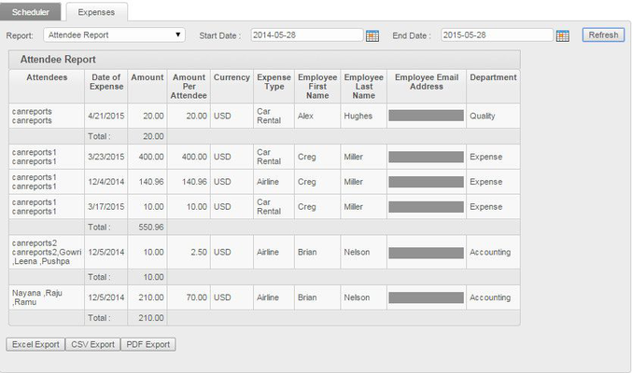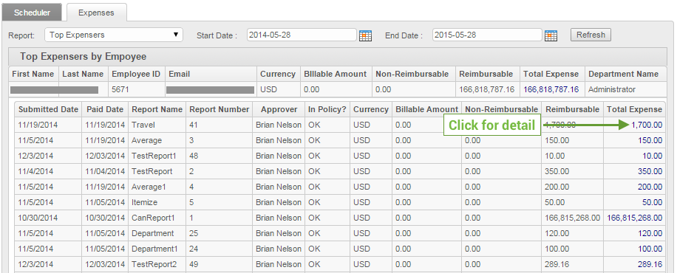

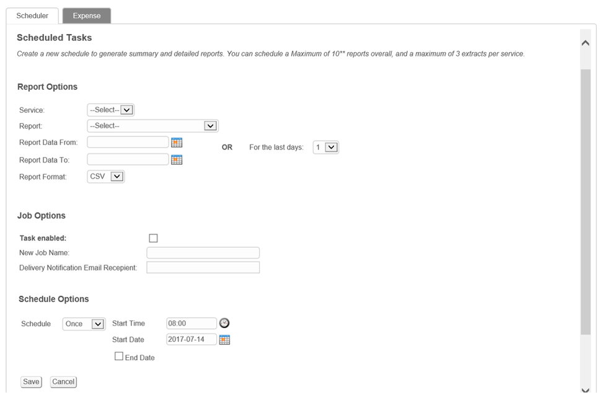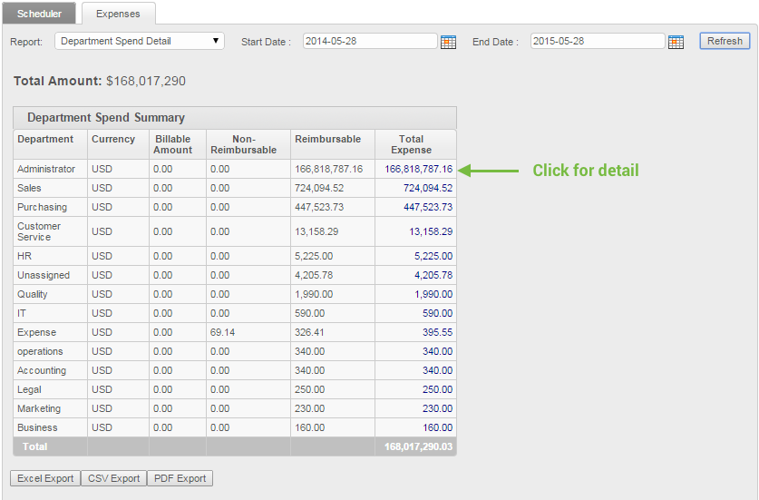

**Pricing**

|  |  |
| --- | --- |
| **Product Items** | **Pricing** |
| Implementation Fee  The initial investment includes Deem best practice consulting and design services. Your company will have access to a Project Specialist who will collaborate with your team to ensure the project milestones are established and resource alignment is achieved to ensure a seamless deployment. This is a one-time fee. | **$XXXX** |
| **Per Expense Report Fee**  The fee structure is based on a per report formula. There are *no hidden fees*, *no additional ‘add-on’ fees -* the base fee is all inclusive. Key deliverables include:   * Expense report automation * Mobility application --- One application for travel, expense, approvals and imaging: all functionality available on smartphones – ‘on the go’ * Imaging – Receipt Management with OCR technology * Business Analytics – Best practice insights * Training – Ongoing training and self-help resources available on Deem portal; FAQ, videos, quick start guides   Support services – Deem designated employees for online second level | **$5.50 per Expense Report**  Overages will be reconciled at the end of the billing cycle and charged at the same fee = $5.50. No incremental fee is assessed for overages |
| Optional Service - ACH | **$29/ per administrator per month; and $0.49 per ACH** |
| Notes: | Proposal assumes a minimum of 1560 Expense Reports submitted annually.  Contract term of 36 months.  Pricing expires 12/31/17 |