Customers to send to travelers: Etta is available for download (Android and iOS)

Subject  [Not to exceed 50 characters] | Now available: Etta mobile app
Primary Msg: Body Content | {{FIRSTNAME}},  With Etta, powered by Deem, you get a beautiful and effortless corporate travel solution that simplifies how you fly. And now that Etta is available on both iOS and Android, you get more support for:  - Streamlined booking and modifications  - Faster travel searches and more airfare options  - Accessibility features to enable every body  Download the Etta mobile app today.  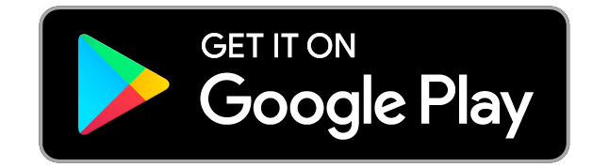  Best regards,  {{PERSON’S SIGNATURE}}

