TMC to send to customers: Etta mobile app is now available (Android and iOS)

Subject  [Not to exceed 50 characters] | Streamline your travel program the easy way
Primary Msg: Body Content | {{FIRSTNAME}},  Now arriving in the first-class terminal: Etta mobile app for iOS and Android.  With Etta, powered by Deem, you get an effortless global travel management platform that improves adoption and controls spending by giving your travelers:  - Simplified booking and modifications  - Faster travel searches and more airfare options  - Superior duty of care functionality  Download Etta today.  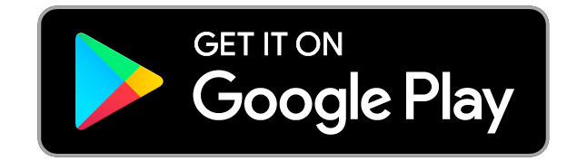  Best regards,  {{PERSON’S SIGNATURE}}
CTA | Get my Etta launch kit

